CHAPTER IV

RESULTS AND DISCUSSIONS

This chapter presents the results of the system design, development, testing, and evaluation of the Web-Based QR-Enabled Pet Registration, Vaccination, and Traceability Management System with Payment Monitoring and Data Analytics for the City Veterinary Animal Clinic in Cabuyao City, Laguna. The discussion is organized according to the specific objectives of the study to ensure that each objective is addressed by corresponding results and interpretations. The chapter presents the implemented system modules together with their interfaces, the unit and integration testing results, and the performance evaluation conducted by the identified stakeholders.

I. Results of System Design and Development Per Module

This section presents the results of the design and development phase of the system. It demonstrates how the identified user requirements, functional requirements, and technical requirements were translated into the proposed system architecture, interfaces, database, processes, and other design components.
The system is composed of seven (7) modules, namely the User Management and Authentication Module, the Pet Registration Module, the QR Code Generation and Traceability Module, the Vaccination Management Module, the Payment and Payment Receipt Monitoring Module, the Records Management Module, and the Data Analytics and Reporting Module. Each module was designed and developed based on the requirements identified in the previous chapters.

User Management and Authentication module is designed to manage user accounts and control access to the system according to the assigned role. It was developed to support pet owner self-registration, administrator-managed staff and veterinarian accounts, authentication, and role-based authorization. The module provides functions such as login and logout, password recovery, user directory management, user status management, and role-based access. When a user submits valid credentials, the system authenticates the account, identifies the assigned role, and provides access only to the functions authorized for that role.
Pet Registration module is designed to provide a structured digital process for recording pet and owner information. It was developed to provide forms for recording required pet and owner details, uploading a pet photo, preventing duplicate entries, and assigning a unique pet code to registered pets. The module also supports saving a registration as a local draft when the required network connection is unavailable and submitting the registration for clinic verification when the user can continue the process. After verification, the registration status is updated in the system and the corresponding pet record becomes available for authorized functions.
QR Code Generation and Traceability module is designed to provide each verified pet with a unique QR identifier that supports pet identification and access to its digital record. Once a pet registration is verified, the module generates and stores the QR information and links it to the public digital pet profile. The module also supports QR-based retrieval of pet information and administrative monitoring of traceability-related records. When a QR code is scanned, the system identifies the corresponding pet and displays the available digital pet information associated with that code.
Vaccination Management module is designed to record and monitor the vaccination history of registered pets. It provides available vaccine and schedule information, allows authorized Staff and Veterinarian users to record vaccinations, computes the next due date according to the configured schedule, and updates the vaccination status. Pet owners can

view the vaccination history of their pets, while applicable reminders can be generated for vaccination-related updates. After a vaccination is recorded, the system saves the record, updates the pet's vaccination information and status, and makes the updated information available through the appropriate interfaces.
Payment and Payment Receipt Monitoring module is designed to monitor payment transactions and associate Payment Receipt information with the appropriate pet or registration record. It was developed based on the requirement for the City Veterinary Office to maintain an organized digital record of payments and Treasury-issued Payment Receipts while recognizing that the City Veterinary Office and City Treasury are separate offices. Its major functions include recording payment details and Payment Receipt information, reviewing submitted payment records, verifying payments, and viewing payment history. The module does not directly access the Treasury database. After payment information is submitted or recorded, the system stores the transaction and makes it available to authorized staff for verification and monitoring.
Records Management module is designed to manage the veterinary records of registered pets and process requests for copies of records. It was developed based on the requirement that authorized clinic personnel can record and retrieve consultation and medicine information and that pet owners can request copies of their pet records. Its major functions include viewing pet records, recording consultations and medicine information, processing record requests, and generating and issuing requested records as PDF files. After a record is entered or a request is processed, the system stores the information and updates the corresponding record or request status for authorized users to review.
Data Analytics and Reporting module is designed to support administrative monitoring by presenting summaries and reports derived from the records stored in the system. It was developed based on the requirement that the administrator can monitor pet registration information and review summarized data for management purposes. Its major functions include viewing key indicators in the administrator dashboard, examining barangay-level registration data, reviewing available analytics, and generating or exporting

reports in PDF and Excel formats. After the administrator selects the required dashboard or report function, the system retrieves and aggregates the relevant stored data and presents the results through charts, tables, or downloadable reports.

Screenshots of System Design and Development Per Module
This section presents the screenshots of the developed system interfaces for each module. The screenshots were captured from the running system using the actual functions of each module. For every module, the presentation explains what the module is designed to accomplish, how the module was developed based on the requirements and the system design, the major functions that the users can perform, how the users use the interface to perform a specific task, and what happens after the user performs the required action.

User Management and Authentication Module
The User Management and Authentication Module is designed to manage user accounts and control access to the system according to the assigned role. It was developed based on the requirement that users must be authenticated and authorized before accessing protected functions, while the administrator must be able to manage staff and veterinarian accounts. Its major functions include user login and logout, pet owner account self-registration, creation and management of staff and veterinarian accounts by the administrator, password recovery, user status management, and role-based access control.

To use the interface, the user enters the registered email address and password in the login form shown in Figure 2; the administrator manages user accounts through the User Directory shown in Figure 3, while a prospective pet owner creates an account through the registration interface shown in Figure 4. After the user submits the required action, the system validates the information, authenticates the
account when applicable, and provides access to the functions authorized for the user's role or displays the appropriate validation message when the action cannot be completed.
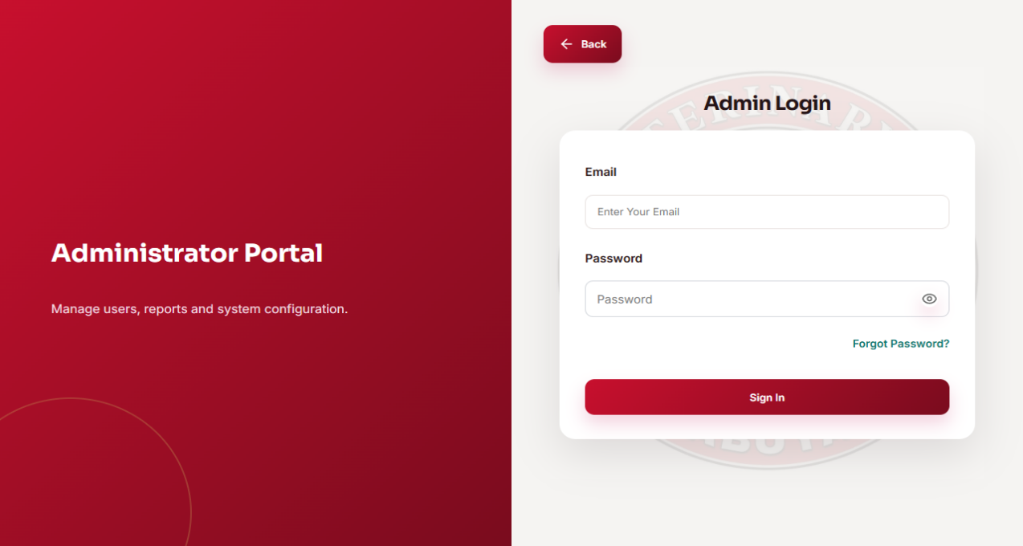

Figure 1. The administrator login interface used to authenticate the user before accessing authorized administrative functions.

The Administrator Login interface is designed to authenticate the administrator and control access to administrative functions. It was developed based on the requirement for role-based authentication, secure account validation, and restricted access to protected system functions. Its major functions include accepting the registered email address and password and providing access to functions authorized for the administrator role. To use the interface, the administrator enters the required credentials and submits the login form. After submission, the system validates the credentials and, when authentication is successful, establishes the user session and opens the appropriate administrative interface; otherwise, it displays the applicable validation message.

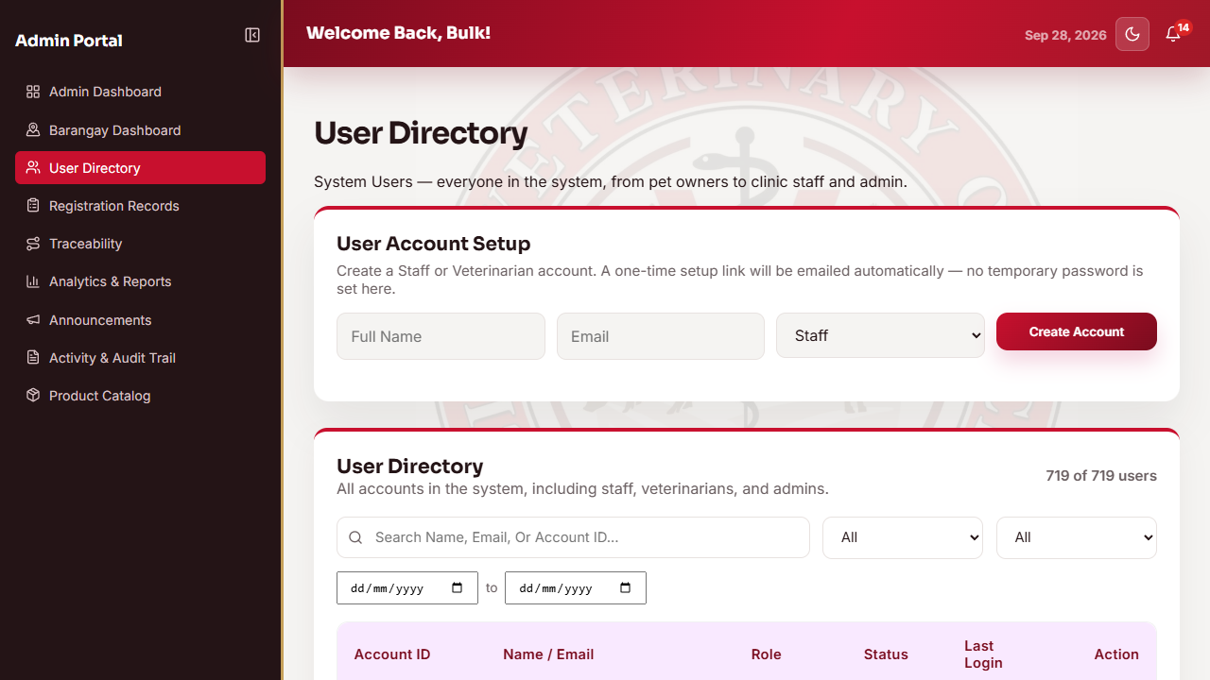

Figure 2. The User Directory interface used by the administrator to manage user accounts and assigned roles
The User Directory interface is designed to provide the administrator with centralized management of system user accounts. It was developed based on the requirement that administrator-controlled accounts, particularly Staff and Veterinarian accounts, must be maintained with appropriate roles and account status. Its major functions include viewing user accounts, managing account information and status, and maintaining the assigned role of each managed user. To use the interface, the administrator selects a user account from the directory and performs the available account-management action. After the action is submitted, the system validates and saves the changes and updates the displayed user information and access status.

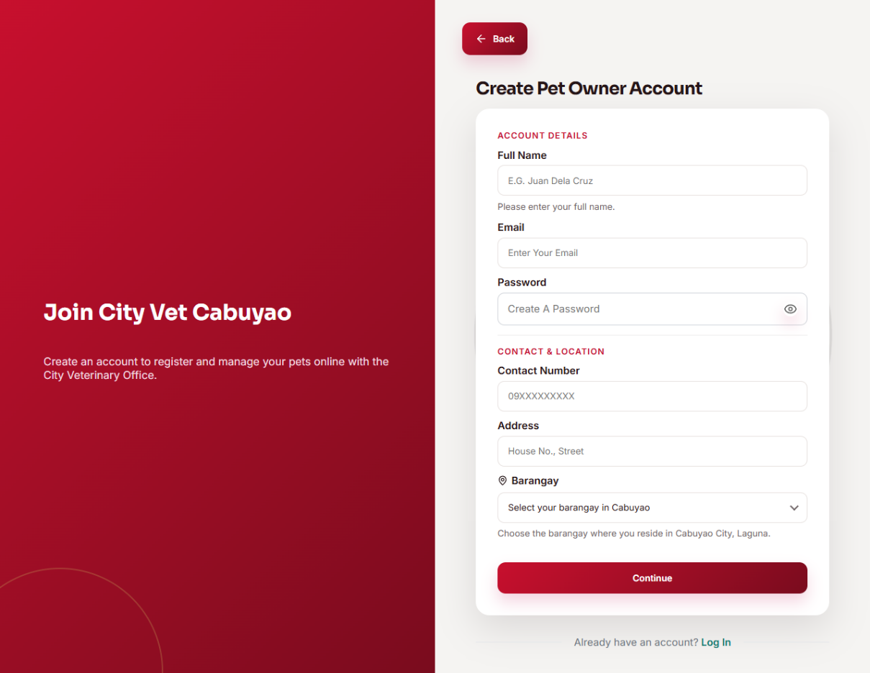

Figure 3. The pet owner account registration interface used to create a Pet Owner account

The Pet Owner Account Registration interface is designed to allow a prospective pet owner to create a personal account for accessing the pet owner functions of the system. It was developed based on the requirement for self-service account creation so that pet owners can register without requiring the administrator to create every owner account manually. Its major functions include entering the

required account information and submitting the registration form. To use the interface, the prospective pet owner completes the required fields and submits the registration request. After submission, the system validates the provided information, creates the account when the requirements are satisfied, and provides the appropriate confirmation or validation message.

Pet Registration Module
The Pet Registration Module is designed to provide a structured digital process for recording pet and owner information and maintaining a centralized registration record. It was developed based on the requirement that pet owners can submit pet information online while authorized clinic personnel can review and verify submitted registrations. Its major functions include encoding pet owner and pet information, uploading a pet photo, preventing duplicate registrations, assigning a unique pet code, saving a registration draft when applicable, and verifying submitted registrations. To use the interface, the pet owner completes the registration form shown in Figure 5 and submits the required information; the authorized staff user reviews the submitted registration in the verification page shown in Figure 6, while the administrator can view the resulting registration records in Figure 7. After submission and verification, the system validates and stores the registration, updates its status, and makes the verified pet record available to the appropriate system functions.

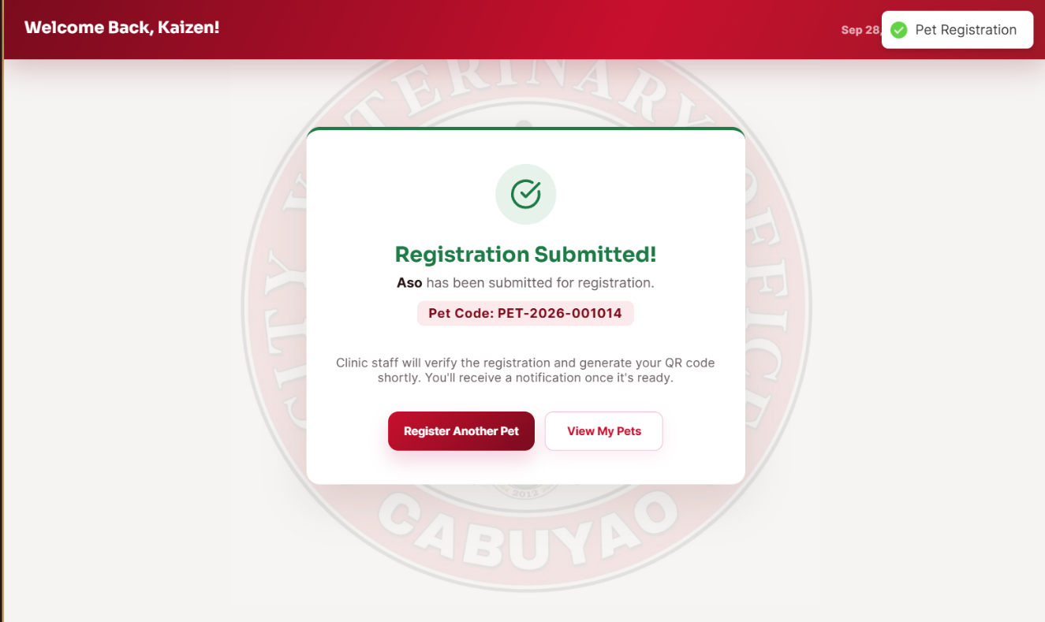
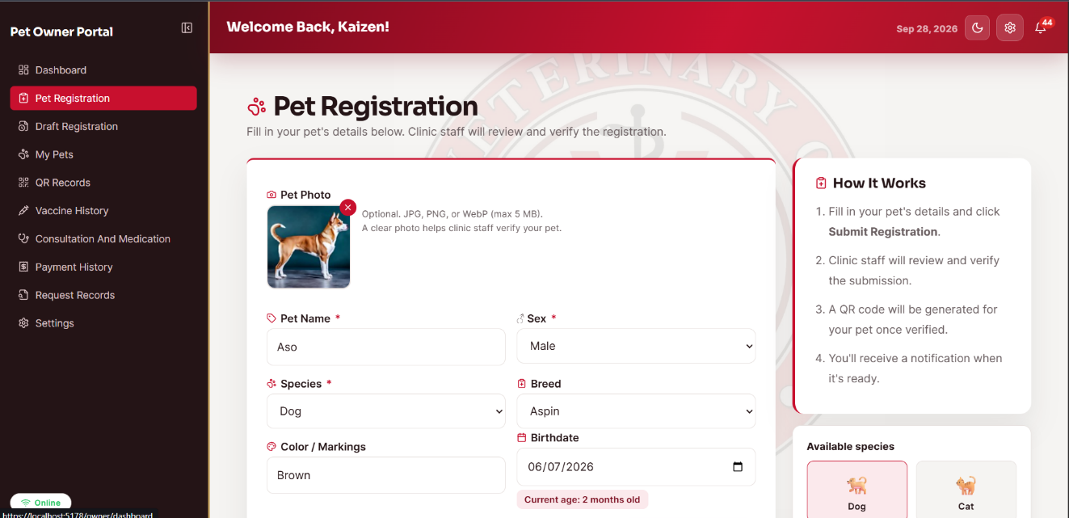

Figure 4. The pet registration interface used to record the required information of a pet and its owner

The Pet Registration interface is designed to provide a structured digital process for recording pet and owner information and creating a centralized registration record. It was developed based on the requirement that pet owners can submit registration information online while the clinic can later review and verify the submitted record. Its major functions include recording owner and pet details, uploading the pet photo, validating required information, preventing duplicate registration, and preparing the record for verification. To use the interface, the pet owner completes the required fields and submits the registration; when network connectivity is unavailable, the registration can be saved as a local draft for later completion. After a successful submission, the system validates and stores the registration, updates its status, and makes the submitted record available to the authorized clinic personnel for verification.
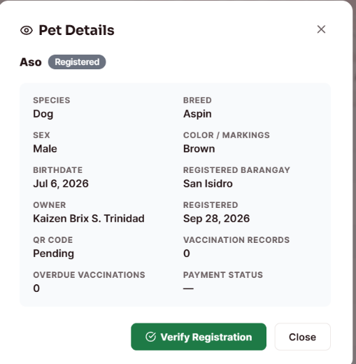
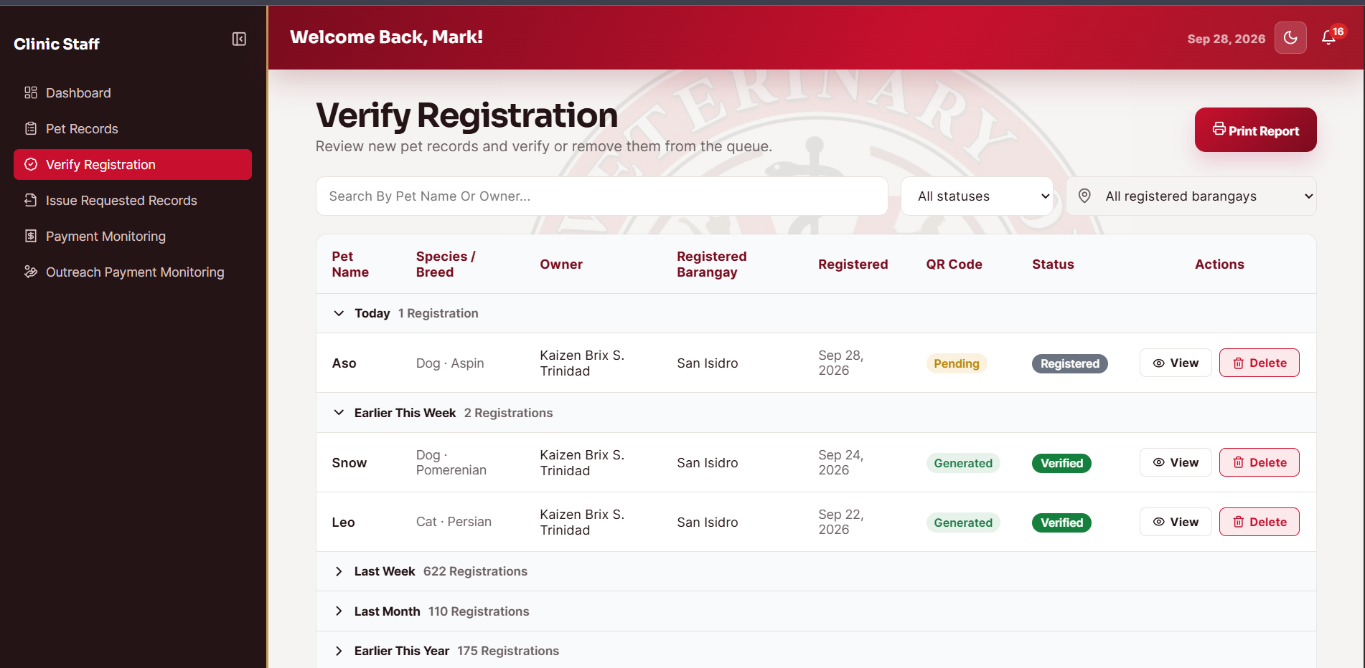

Figure 5. The registration verification interface used by authorized clinic personnel to review submitted pet registrations

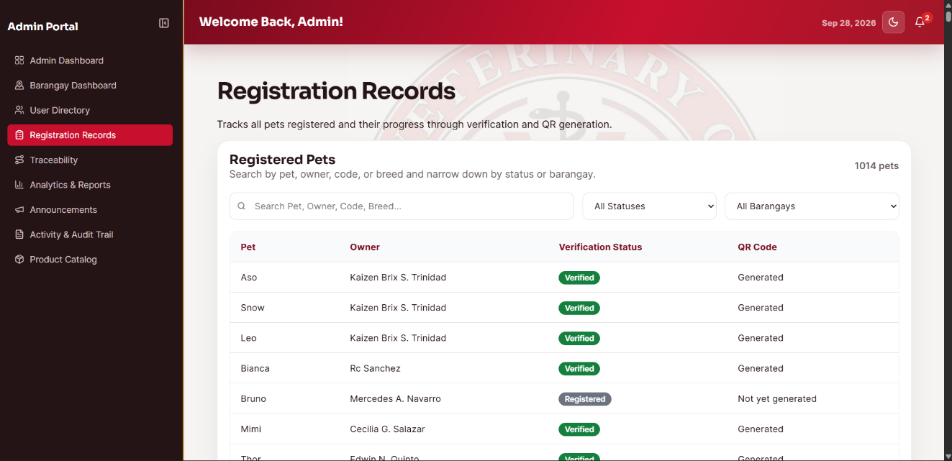
The Registration Verification interface is designed to allow authorized clinic personnel to review submitted pet registrations before they become verified records. It was developed based on the requirement that submitted information must be checked by the clinic before the registration is accepted into the verified system records. Its major functions include displaying pending registrations, reviewing the submitted pet and owner information, applying the available verification action and real time notification in email. To use the interface, the authorized Staff user selects a pending registration, reviews the displayed details, and completes the verification action. After the action is completed, the system updates the registration status and makes the verified record available to the succeeding system functions, including QR generation and record management.

The Registration Records interface is designed to provide the administrator with a centralized view of pet registration records stored in the system. It was developed based on the requirement that the administrator must be able to monitor registration information and review the resulting records after submission and verification. Its major functions include displaying registered pet records and presenting the stored registration information for administrative monitoring. To use the interface, the administrator opens the registration records page and selects or reviews the displayed records. After the system retrieves the records, the selected registration information is presented using the available interface controls for administrative viewing.

QR Code Generation and Traceability Module
The QR Code Generation and Traceability Module is designed to provide each verified pet with a unique QR identifier that supports pet identification, digital record retrieval, and traceability monitoring. It was developed based on the requirement that registered pets should have a scannable identifier linked to their digital pet information. Its major functions include generating a QR code after verification, displaying the QR code to the pet owner, retrieving the corresponding pet profile after scanning, and monitoring traceability information.
To use the interface, the pet owner views the registered pets and their QR codes in the My Pets page shown in Figure 8 and the QR Records page shown in Figure 9; the administrator can monitor traceability information in Figure 10; and scanning a printed QR code opens the public digital pet profile shown in Figure 11. After the QR code is scanned, the system resolves the identifier, retrieves the corresponding pet information, and displays the available digital pet record without requiring the user to log in to the public profile.

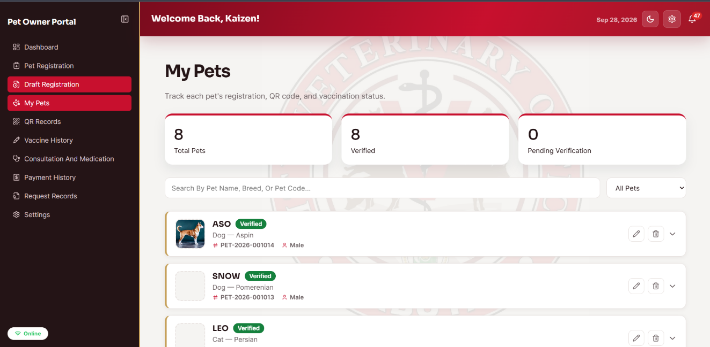
Figure 7. The My Pets interface displaying the registered pets and their generated QR codes

The My Pets interface is designed to allow the pet owner to view the pets associated with the owner account and access their generated QR identifiers. It was developed based on the requirement that verified pets should remain accessible to the owner through a centralized pet list. Its major functions include displaying registered pets and providing access to the QR code associated with each verified pet. To use the interface, the pet owner opens My Pets and selects the registered pet or its available QR function. After the selection, the system retrieves the corresponding pet record and displays the available pet information and QR identifier associated with that record.

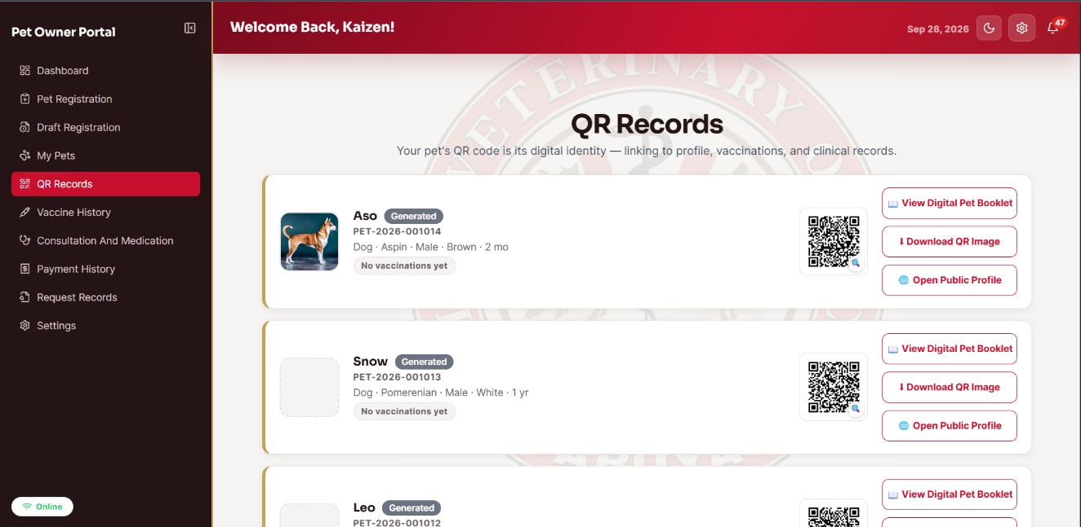
Figure 8. The QR Records interface listing the generated QR records associated with the pet owner's registered pets

The QR Records interface is designed to provide the pet owner with a dedicated view of the QR records generated for the owner's registered pets. It was developed based on the requirement that QR identifiers must be organized and retrievable for verified pets. Its major functions include listing generated QR records and providing access to the QR information associated with each pet. To use the interface, the pet owner opens the QR Records page and selects the desired QR record. After the selection, the system retrieves the corresponding QR information and presents the record associated with the selected pet.

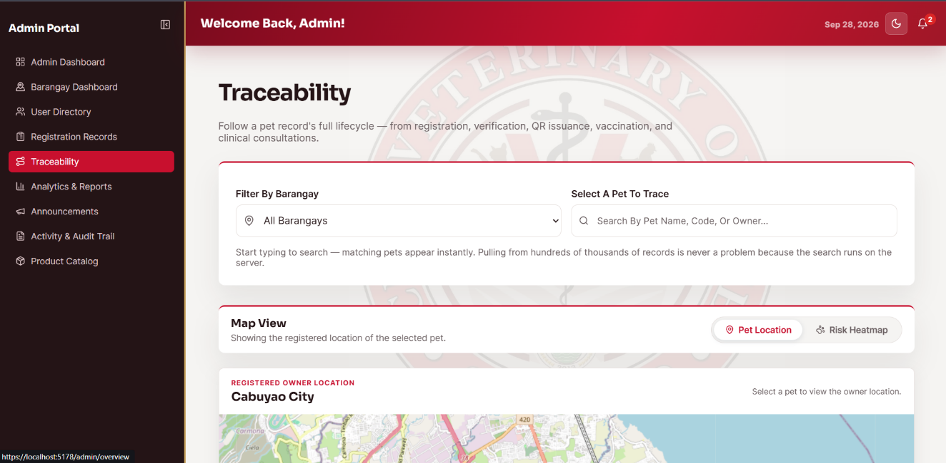
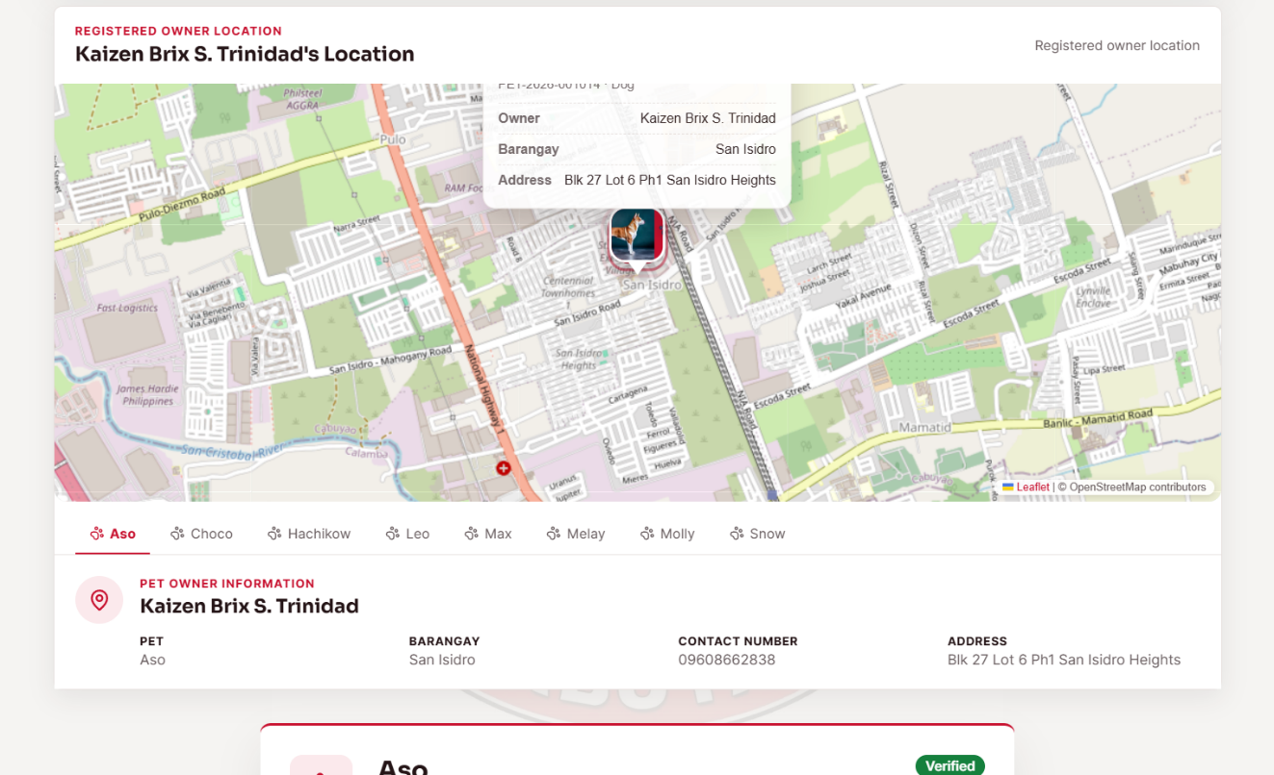

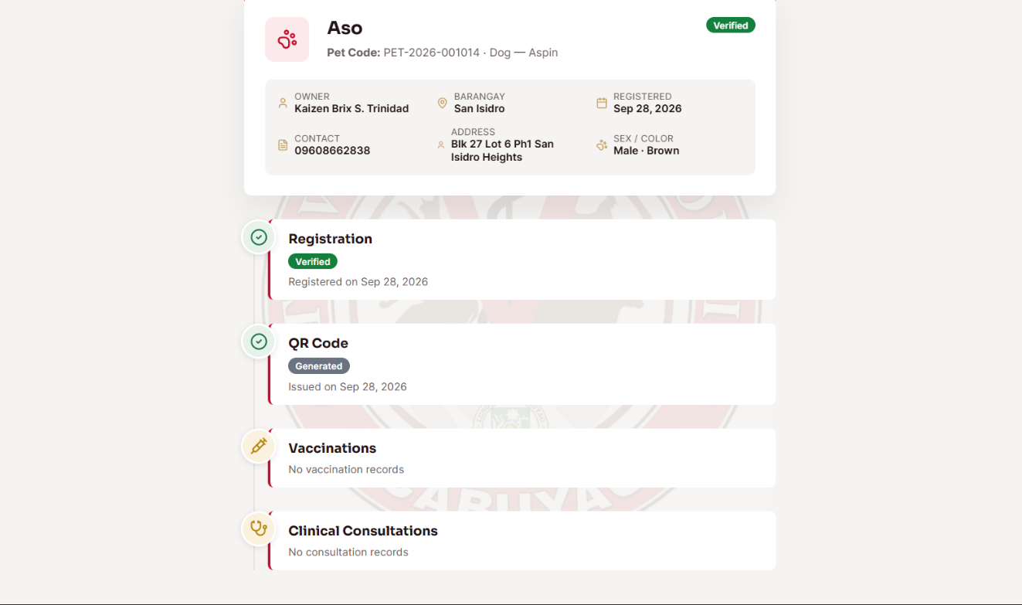

Figure 9. The traceability dashboard used by the administrator to monitor traceability-related pet records
The Traceability Dashboard is designed to support administrative monitoring of traceability-related pet records stored in the system. It was developed based on the requirement that the administrator should have a centralized view for monitoring information related to registered pets and their traceability records. Its major functions include displaying available traceability information and allowing the administrator to review the stored records through the dashboard. To use the interface, the administrator opens the Traceability Dashboard and reviews or selects the available traceability records. After the data are requested, the system retrieves the relevant records from the database and presents the available traceability information through the dashboard interface.

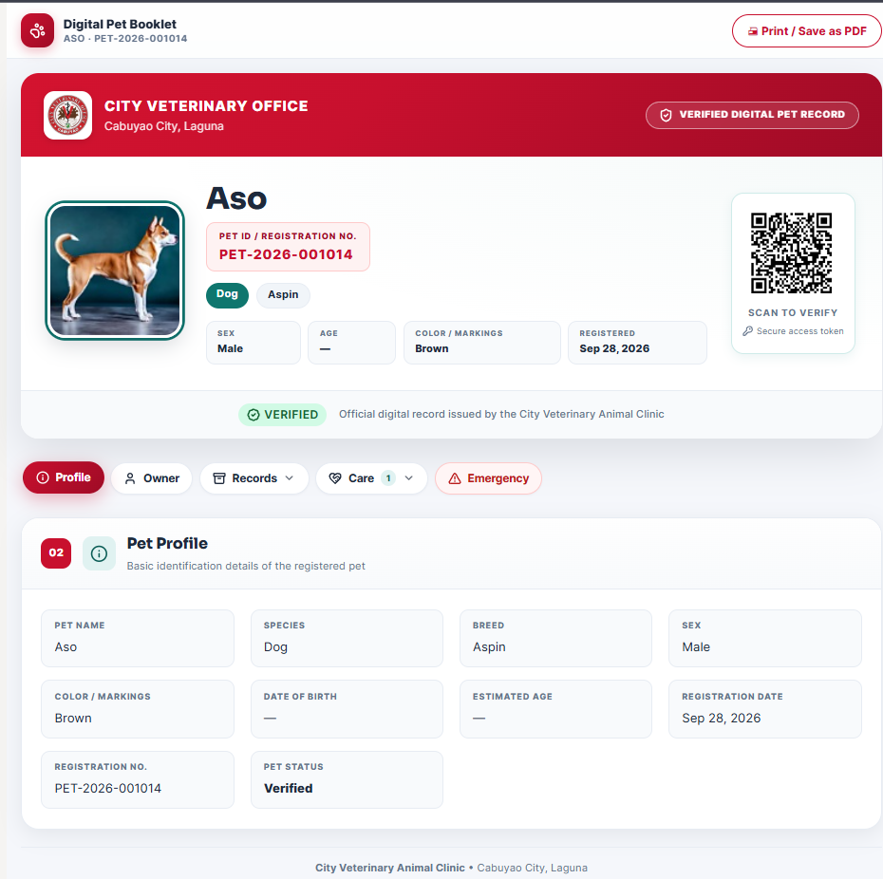

Figure 10. The public pet profile, or digital pet booklet, displayed after the QR code of a pet is scanned
The Public Pet Profile, or Digital Pet Booklet, is designed to provide accessible pet information linked to the pet's QR identifier. It was developed based on the requirement that a verified pet can be identified through a scannable QR code and

that the corresponding digital pet information can be retrieved from that identifier. Its major functions include displaying the pet's available profile and record information associated with the scanned QR code. To use the interface, a user scans the pet's QR code using a compatible device and opens the resulting public profile. After the QR identifier is resolved, the system retrieves the corresponding pet record and displays the available digital pet information without requiring the user to log in to the public profile.

Vaccination Management Module
The Vaccination Management Module is designed to record and monitor the vaccination history of registered pets. It was developed based on the requirement that authorized clinic personnel can encode vaccinations, compute the next due date from the configured vaccine schedule, and maintain the vaccination status of each pet. Its major functions include selecting the vaccine and dose, recording the vaccination date and related information, automatically computing the next due date, updating the vaccination status, and allowing pet owners to view vaccination history. To use the interface, the Staff or Veterinarian selects a pet and enters the vaccination information through the interfaces shown in Figures 12 and 13, while the pet owner can view the resulting vaccination history in Figure 14. After the vaccination is recorded, the system validates and saves the entry, updates the next due date and vaccination status, and displays the updated information in the appropriate user interface.

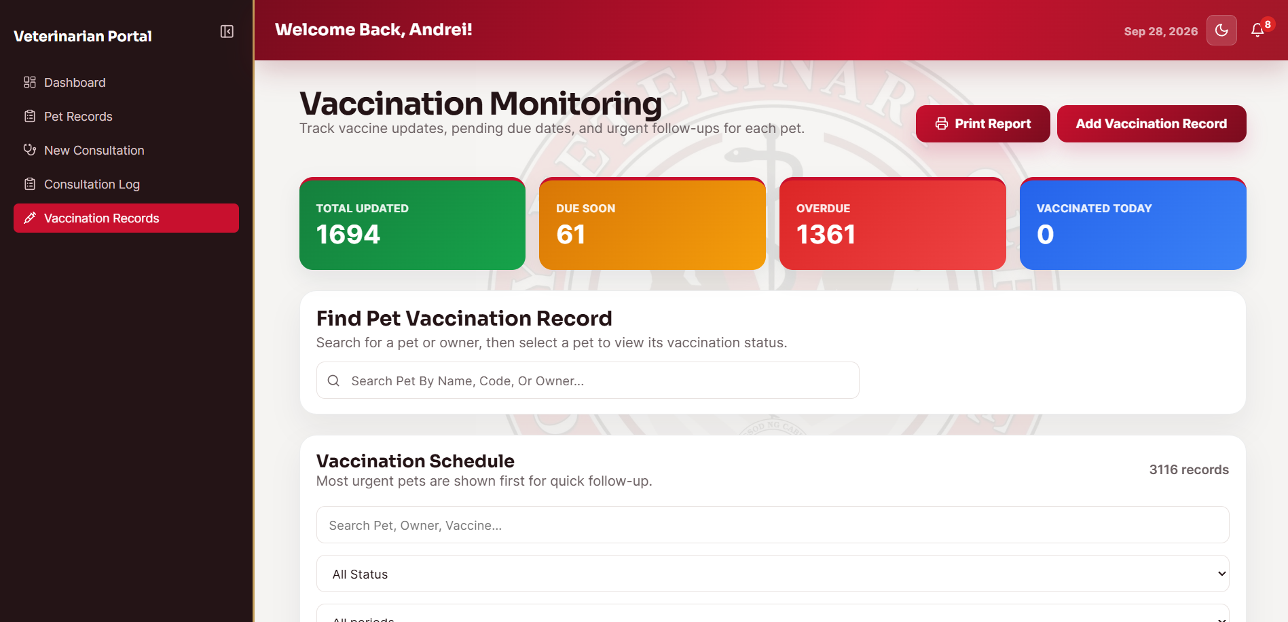
Figure 11. The vaccination records interface used by authorized Staff and Veterinarian users to record and monitor pet vaccinations
The Vaccination Records interface is designed to allow authorized clinic personnel to record and monitor the vaccination status of registered pets. It was developed based on the requirement that Staff and Veterinarian users must be able to maintain current vaccination information for pets receiving veterinary services. Its major functions include locating a pet, viewing existing vaccination records, and accessing the available vaccination-recording functions. To use the interface, the authorized user selects a pet and reviews or updates the vaccination information through the displayed controls. After the action is completed, the system validates and saves the vaccination record and refreshes the pet's vaccination information shown in the interface

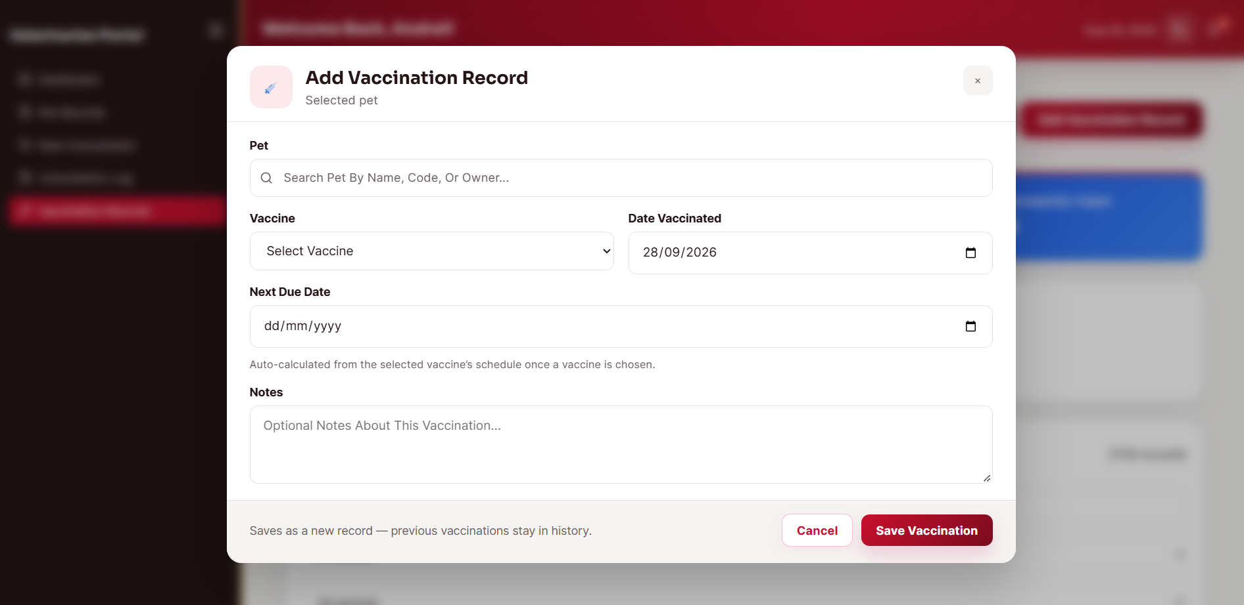
Figure 12. The Add Vaccination Record interface and vaccine schedule used to record a vaccination and determine the next due date

The Add Vaccination Record interface is designed to capture the details of a new vaccination and determine the next scheduled vaccination date. It was developed based on the requirement that vaccination records must contain the appropriate vaccine information, date, and schedule-related details. Its major functions include selecting the vaccine and dose, recording the vaccination date and related information, and using the configured schedule to determine the next due date. To use the interface, the authorized Staff or Veterinarian user selects the pet, enters the vaccination details, and submits the record. After submission, the system validates and stores the vaccination entry, computes the next due date based on the configured schedule, and updates the vaccination status shown in the system.

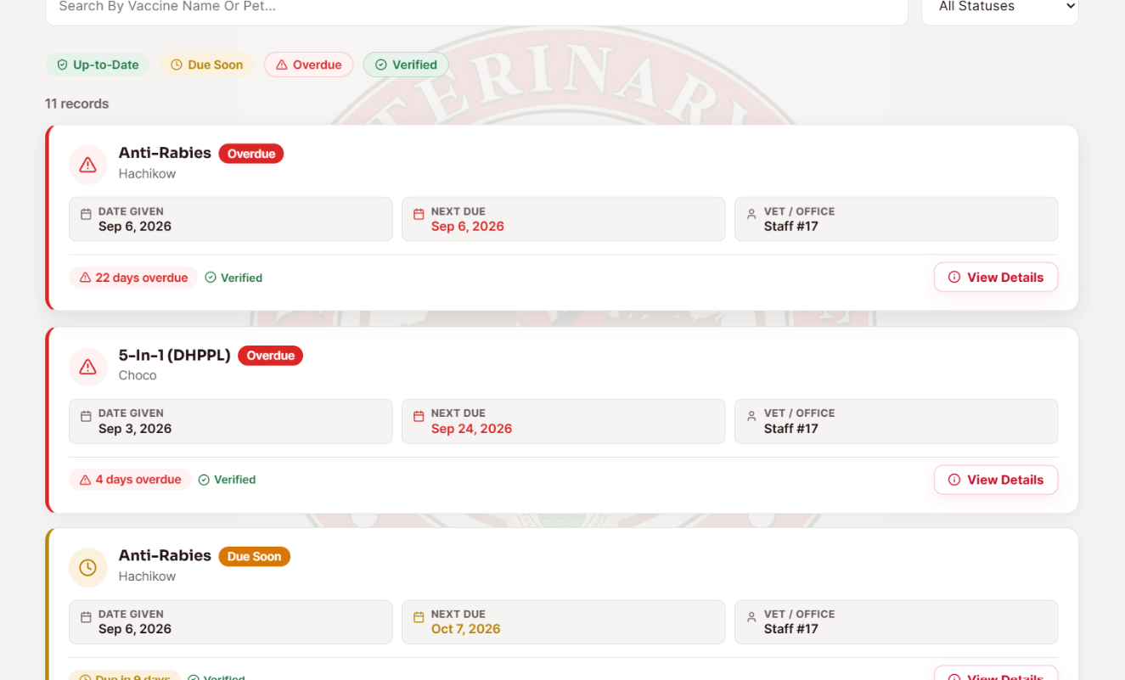
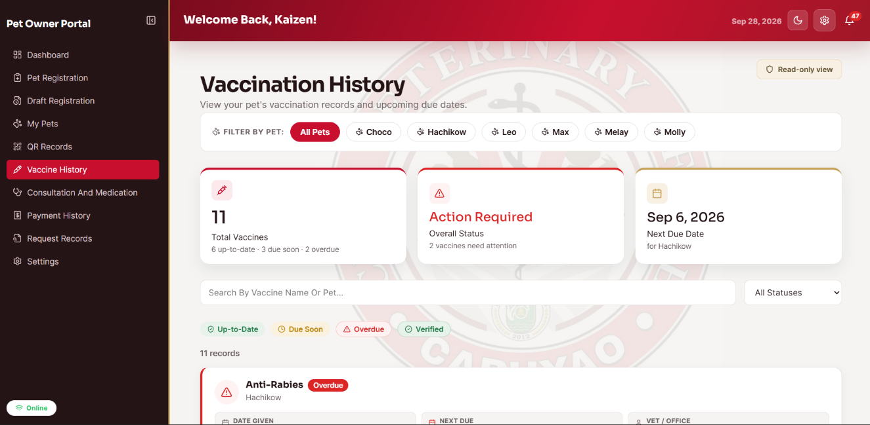

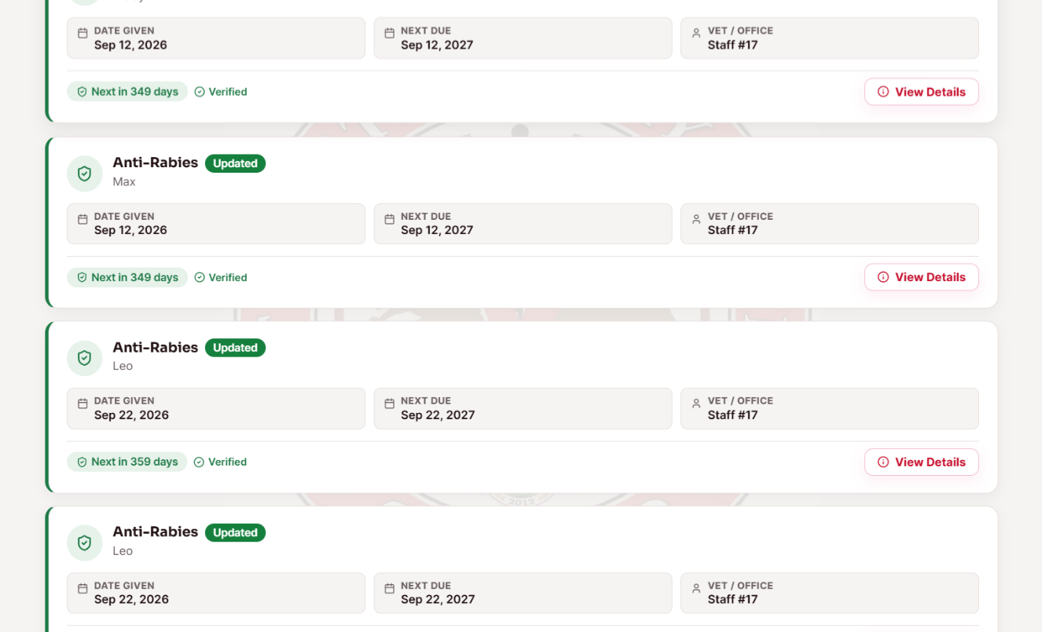
Figure 13. The vaccination history interface displayed to the pet owner for viewing the vaccination records of a pet
The Vaccination History interface is designed to provide the pet owner with a readable history of the vaccinations recorded for a pet. It was developed based on the requirement that pet owners should be able to review their pets' vaccination information through the digital system. Its major functions include displaying previously recorded vaccination entries and the corresponding vaccination details available to the owner. To use the interface, the pet owner opens the vaccination history for a selected pet and reviews the listed records. After the page loads, the system retrieves the stored vaccination information and presents the updated history, including the schedule information recorded for the pet.

Payment and Payment Receipt Monitoring Module.

The Payment and Payment Receipt Monitoring Module is designed to monitor payment transactions and associate Payment Receipt information with the correct pet or registration record. It was developed based on the requirement for the City Veterinary Office to maintain organized payment records and verify payment

information while recognizing that Payment Receipts are issued by the City Treasury and that the two offices do not share a direct database connection. Its major functions include recording payment details and Payment Receipt information, reviewing and verifying submitted payment records, monitoring payment status, and viewing payment history. To use the interface, the pet owner records or submits the required payment information through the payment history interface shown in Figure 16, while the authorized staff user reviews and verifies the payment through the monitoring interface shown in Figure 15. After the payment information is submitted, the system stores the transaction and its Payment Receipt details, updates the payment status after verification, and displays the resulting transaction in the payment history.

Figure 14. The payment monitoring interface used by authorized clinic personnel to review and verify recorded payment information.
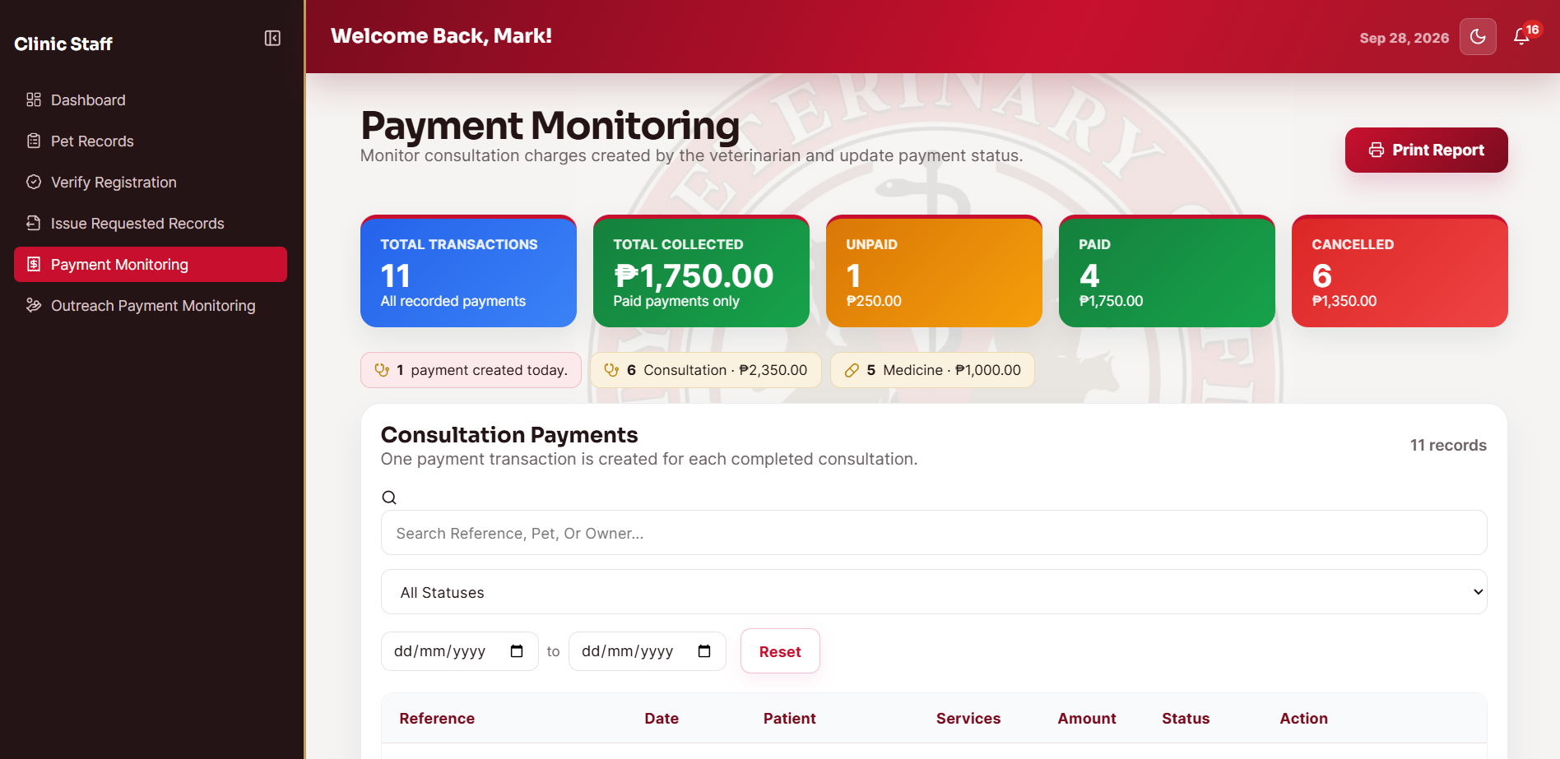

The Payment Monitoring interface is designed to allow authorized clinic personnel to review and monitor payment transactions and their associated Payment Receipt information. It was developed based on the requirement that the City Veterinary Office must maintain organized digital payment records while recognizing that

Payment Receipts are issued by the City Treasury and that the two offices do not share a direct database connection. Its major functions include viewing payment records, reviewing Payment Receipt information, and verifying the recorded payment status. To use the interface, the authorized Staff user selects the relevant payment transaction and reviews the submitted details before applying the available verification action. After the action is completed, the system stores or updates the payment status and displays the resulting transaction in the payment monitoring records; it does not directly query the Treasury database.

Figure 15. The payment history interface displaying the pet owner's recorded payment transactions and Payment Receipt information.
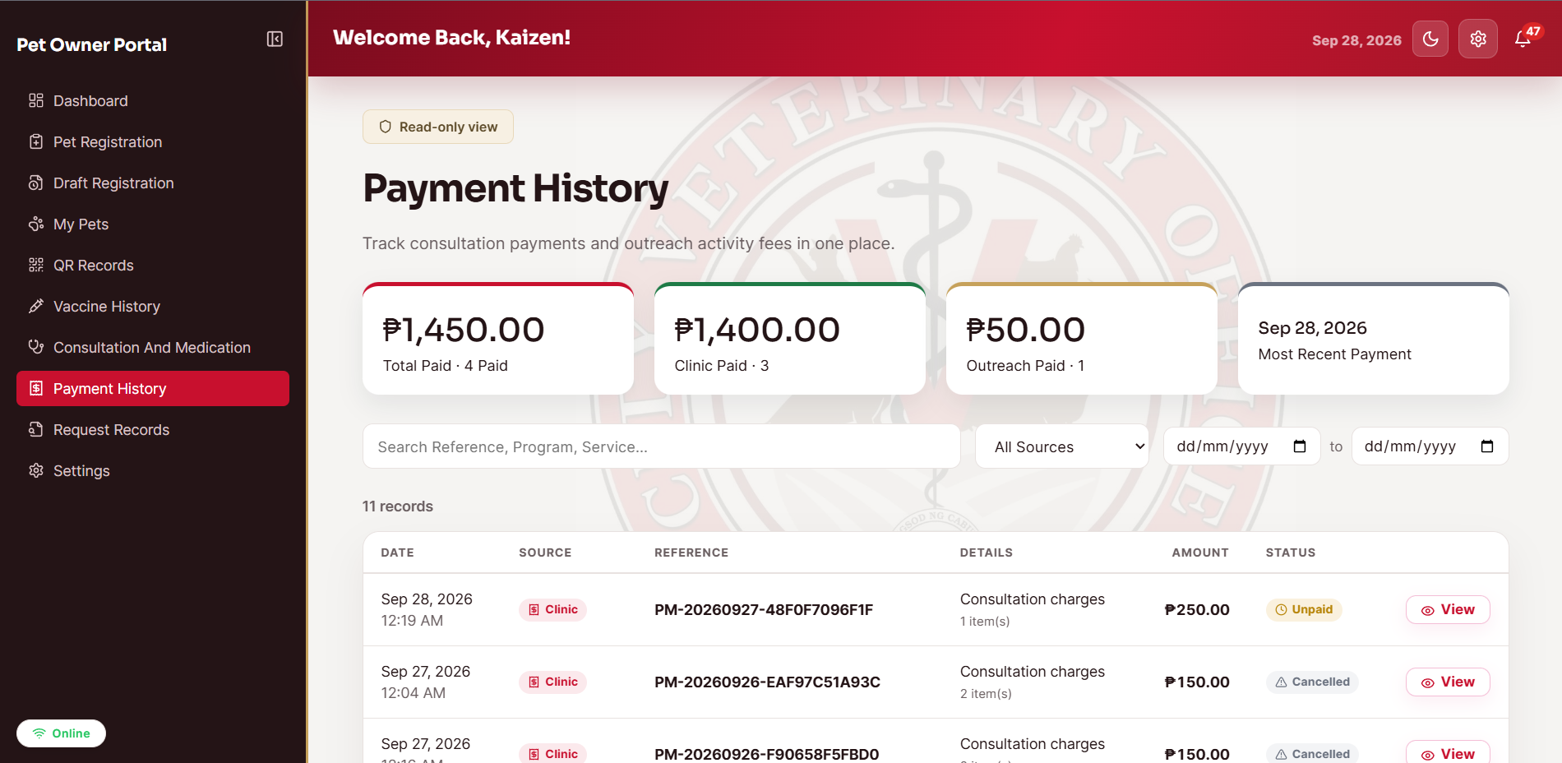
The Payment History interface is designed to allow the pet owner to review the payment transactions and Payment Receipt information recorded for the owner's account or pet records. It was developed based on the requirement that pet owners should be able to monitor the payment information maintained by the City Veterinary Office. Its major functions include displaying recorded payment transactions, payment status, and available Payment Receipt information. To use the interface, the pet owner opens the payment history page and selects or reviews the displayed transactions. After the system retrieves the records, it presents the stored

payment information so that the owner can monitor the status and corresponding receipt details recorded in the system.

Records Management Module.
The Records Management Module is designed to provide authorized users with centralized access to the veterinary records of registered pets and to support the processing of requests for copies of records. It was developed based on the requirement that clinic personnel can record consultations and medicine information and that pet owners can request copies of their pet records. Its major functions include viewing pet records, recording consultation information, recording medicine information, processing record requests, and generating and issuing requested records as PDF files. To use the interface, the authorized user views the pet record in Figure 17, records or reviews consultation information in Figure 18, manages medicine information in Figure 19, and processes the requested record through Figure 20; the pet owner can submit or monitor a record request through Figure 21. After the required action is completed, the system stores the record or updates the request status and, when a record is issued, generates the requested document as a PDF for the authorized recipient.

Figure 16. The pet records interface used by authorized clinic personnel to view the available veterinary records of a pet.
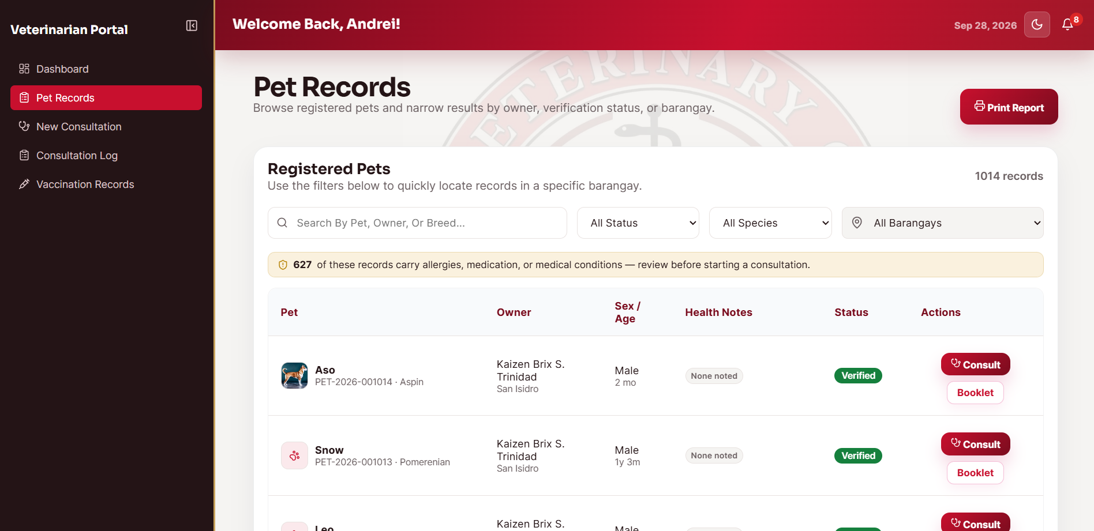

The Pet Records interface is designed to provide authorized clinic personnel with centralized access to the veterinary records associated with a registered pet. It was developed based on the requirement that relevant pet information should be available in one location for authorized clinical and administrative use. Its major functions include viewing the pet profile and the available veterinary records, including vaccination and medical information. To use the interface, the authorized user selects a pet and opens the Pet Records page to review the stored information. After the record is retrieved, the system presents the available data associated with the selected pet and reflects the latest saved information.

Figure 17. The consultation records interface used to record and monitor the consultation information of pets.
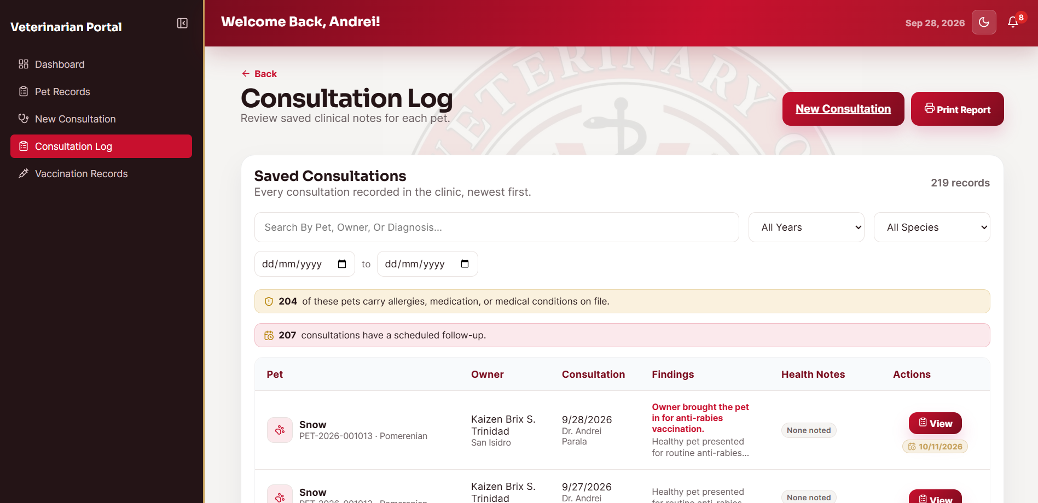

The Consultation Records interface is designed to record and monitor consultation information for registered pets. It was developed based on the requirement that the clinic must maintain structured records of consultations as part of the pet's veterinary history. Its major functions include viewing existing consultation entries and recording the details of a new consultation. To use the interface, the authorized clinic user selects the pet, enters the required consultation information, and submits the record. After submission, the system validates and saves the consultation entry and makes the updated consultation history available in the pet's records.

Figure 18. The medicine records interface used to record and monitor medicine information associated with veterinary care.
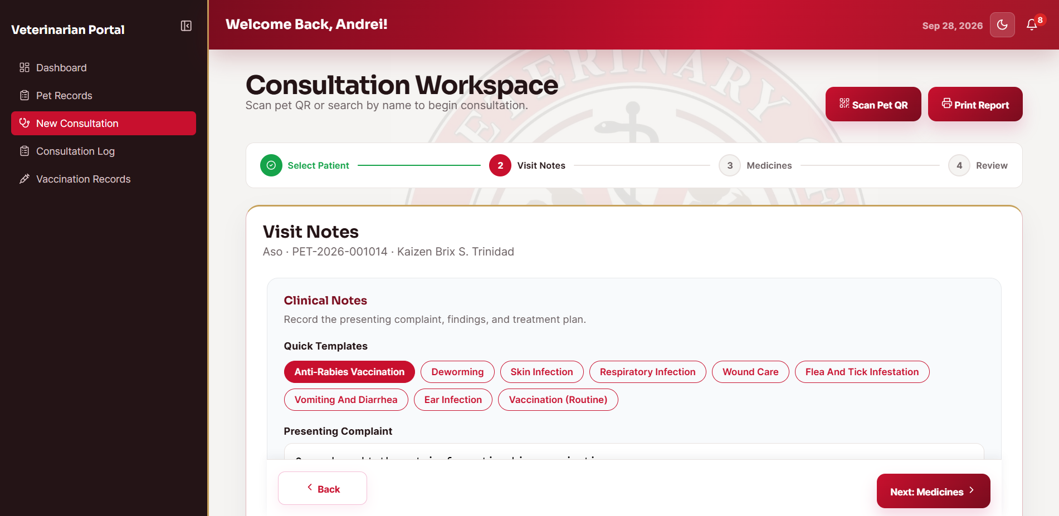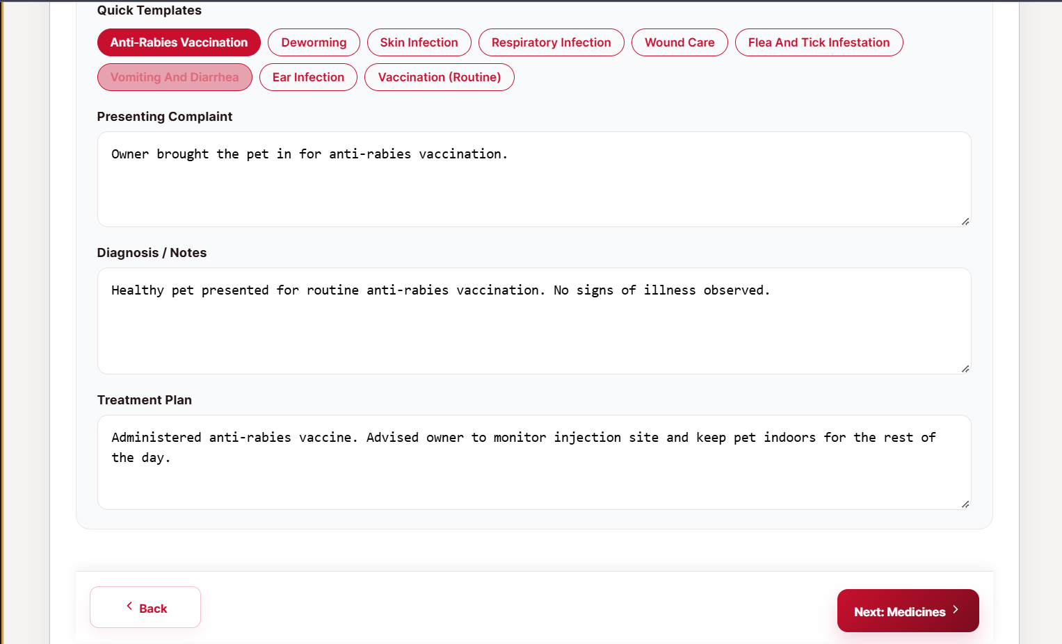

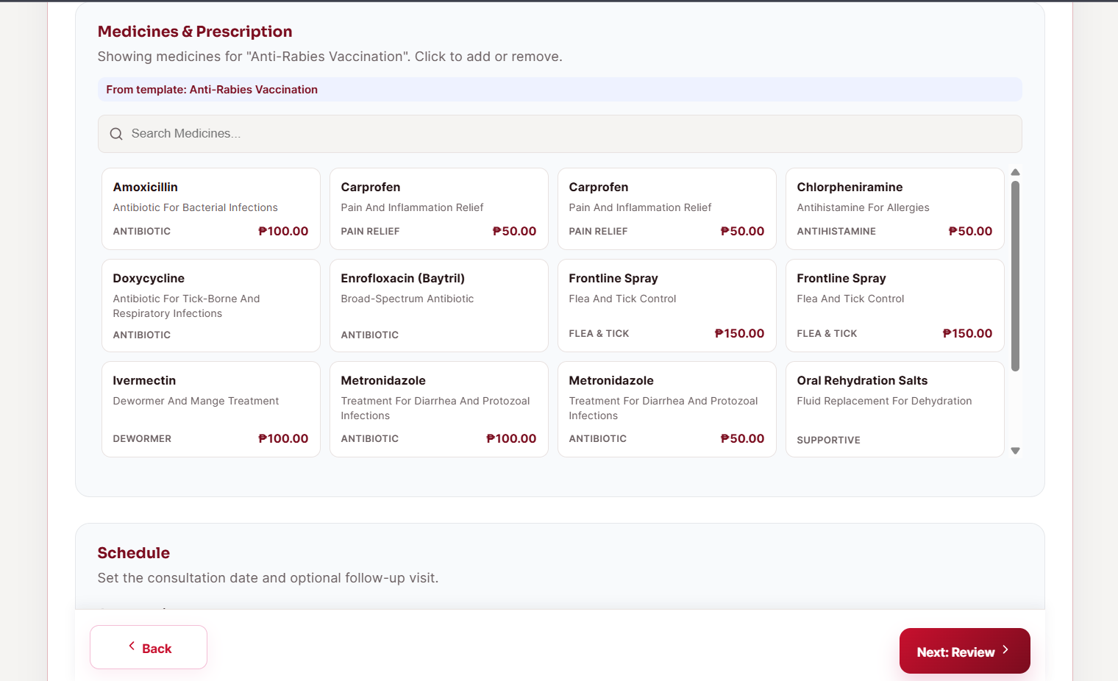
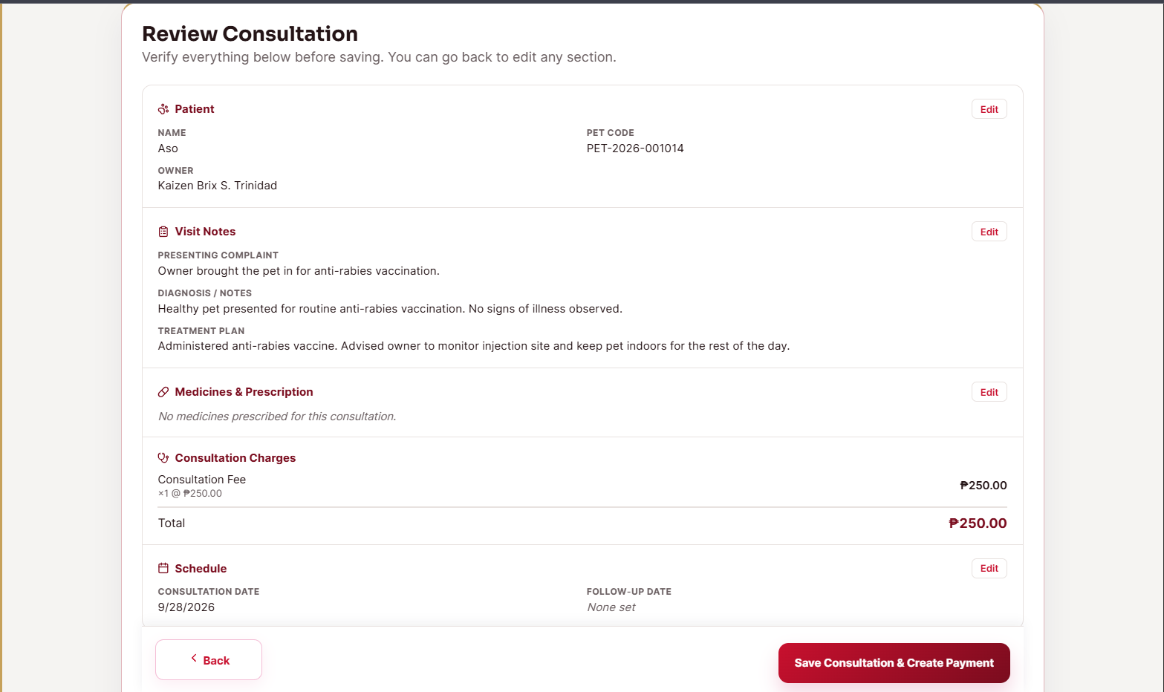

The Medicine Records interface is designed to record and monitor medicine information associated with the veterinary care of registered pets. It was developed based on the requirement that medicine-related information should be stored as part of the pet's clinical record. Its major functions include viewing existing medicine entries and recording the medicine information required by the clinic. To use the interface, the authorized clinic user selects the pet, enters the medicine details, and submits the record through the available controls. After submission, the system validates and stores the medicine entry and updates the pet's records with the newly recorded information.

Figure 19. The issue requested record interface used by authorized clinic personnel to process and issue a requested pet record.
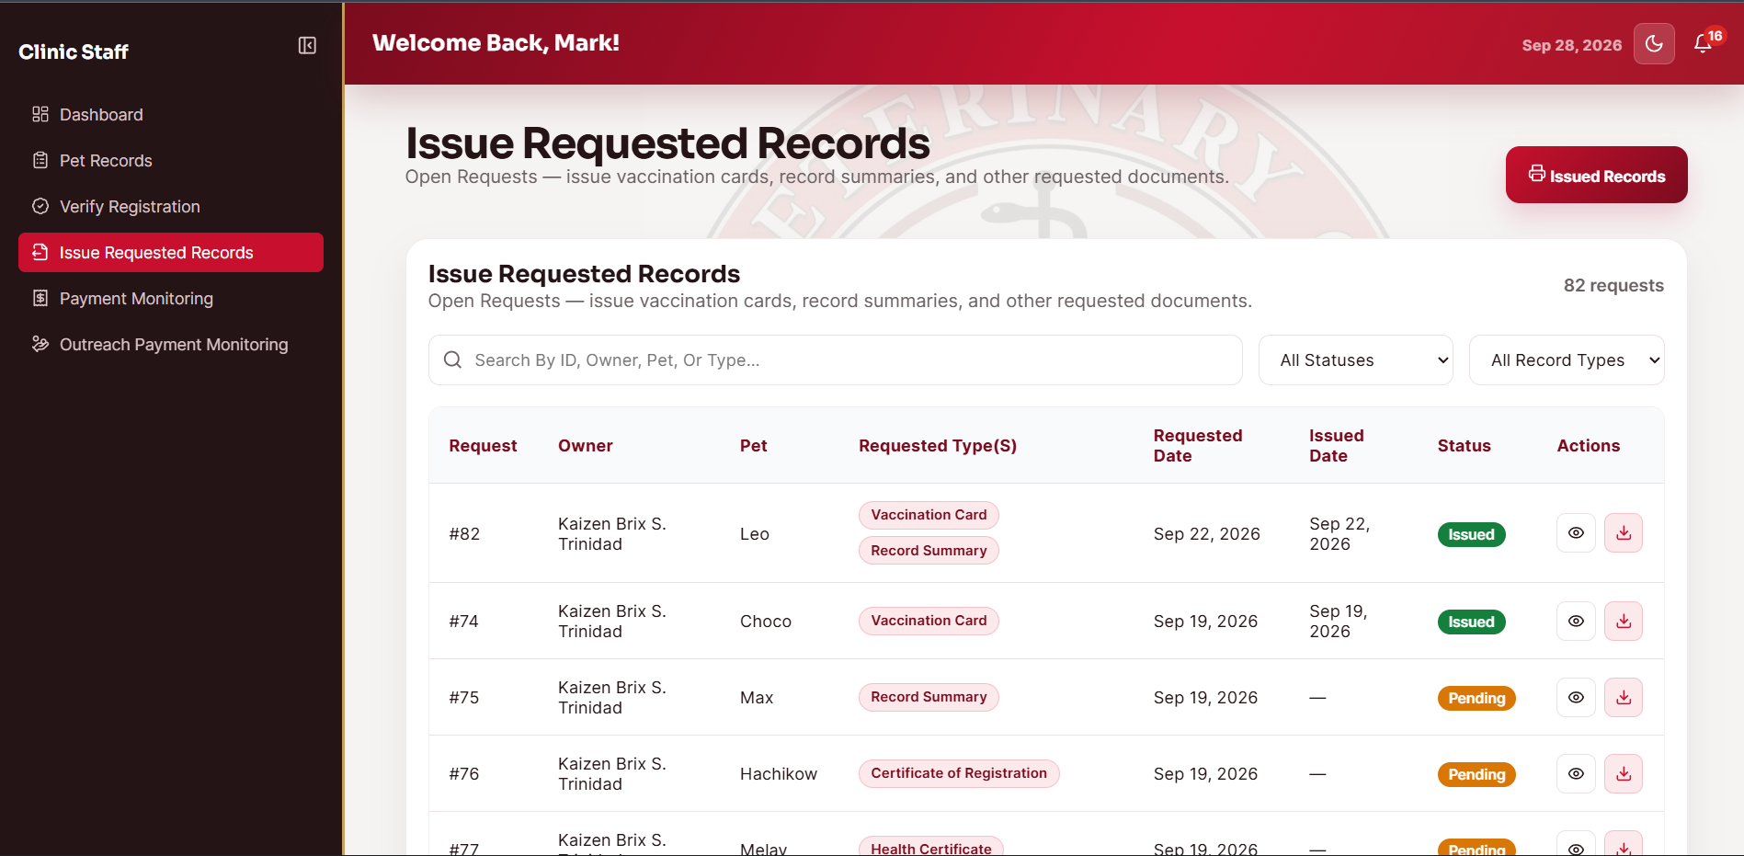

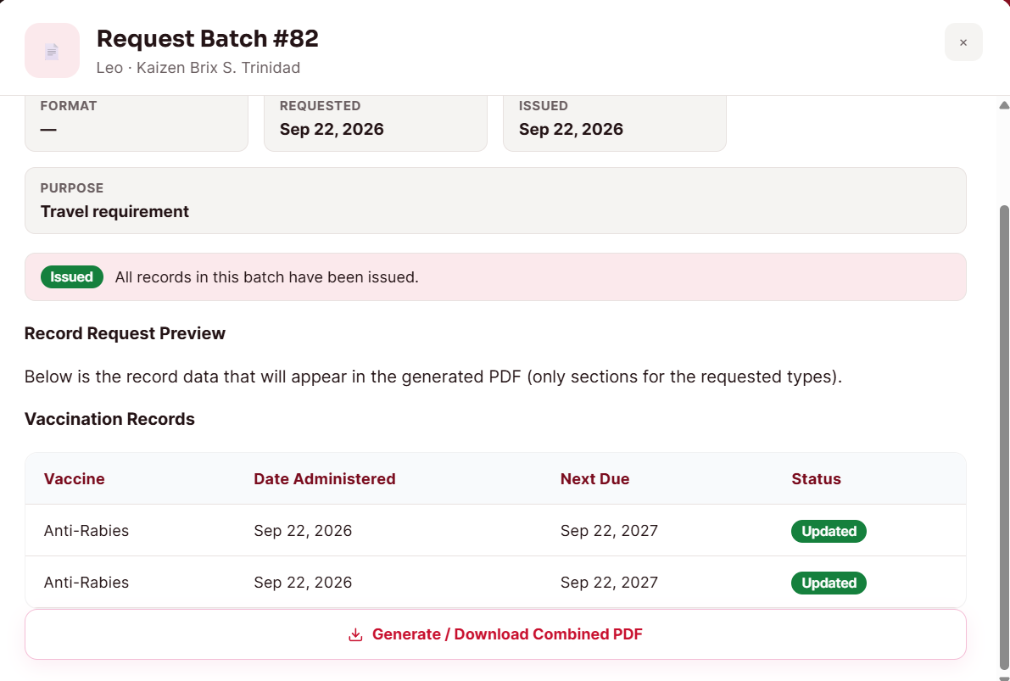
The Issue Requested Record interface is designed to allow authorized clinic personnel to process a pet owner's request for a copy of a veterinary record. It was developed based on the requirement that requested records must be reviewed and issued through a controlled system process. Its major functions include viewing pending record requests, preparing the requested record, and issuing the resulting document. To use the interface, the authorized clinic user selects a pending request, performs the available issue action, and completes the required processing. After processing, the system updates the request status and generates the requested record as a PDF file for the authorized recipient when the request is successfully issued.

Figure 20. The record requests interface used by the pet owner to submit and monitor requests for copies of pet records.
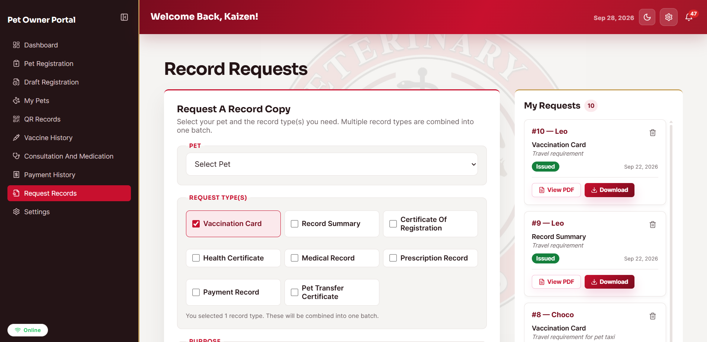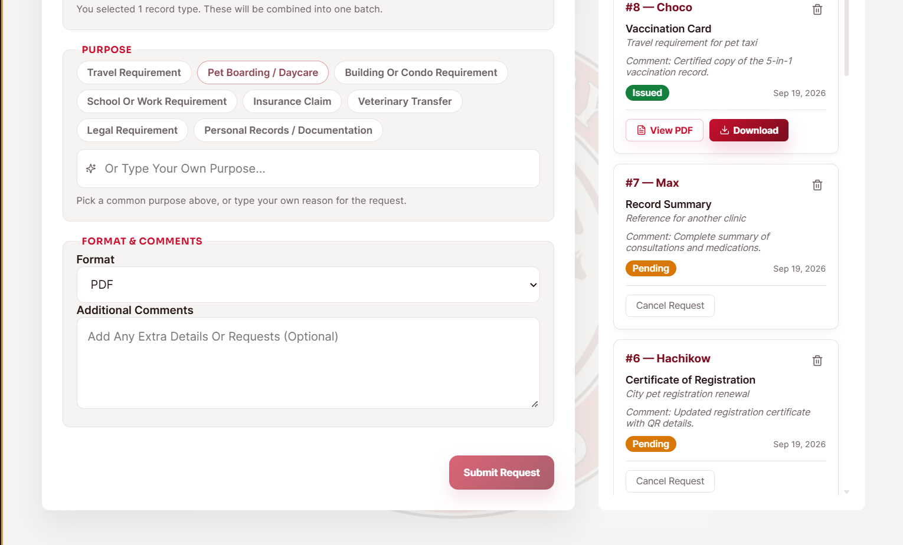

The Record Requests interface is designed to allow pet owners to request and monitor copies of their pets' veterinary records. It was developed based on the requirement that requests for records should be submitted and tracked digitally rather than handled only through manual follow-up. Its major functions include submitting a request for a record and viewing the current request status. To use the interface, the pet owner selects the requested record type, provides the required information, and submits the request through the page. After submission, the system stores the request, assigns its current status, and displays the updated request information so the pet owner can monitor the processing of the request.

Data Analytics and Reporting Module.

The Data Analytics and Reporting Module is designed to support administrative monitoring by presenting summaries and reports derived from the stored system records. It was developed based on the requirement that the administrator can monitor the overall status of pet registration and examine summarized information for management purposes. Its major functions include displaying key indicators in the administrator dashboard, viewing barangay-level pet registration data, reviewing available analytics, and generating and exporting reports in PDF and Excel formats. To use the interface, the administrator views the key indicators in the dashboard shown in Figure 22, selects the required analytics or report functions in Figure 23, and examines barangay-level registration information in Figure 24. After the administrator requests the data or report, the system retrieves and aggregates the relevant records and presents the results through the dashboard, charts, tables, or exported report file.

Figure 21. The administrator dashboard presenting key indicators and summarized information from the system records.
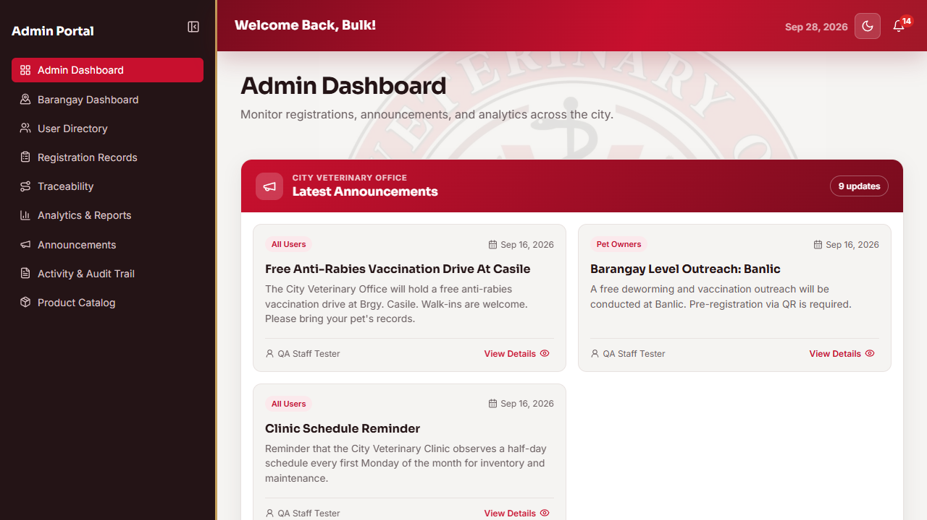

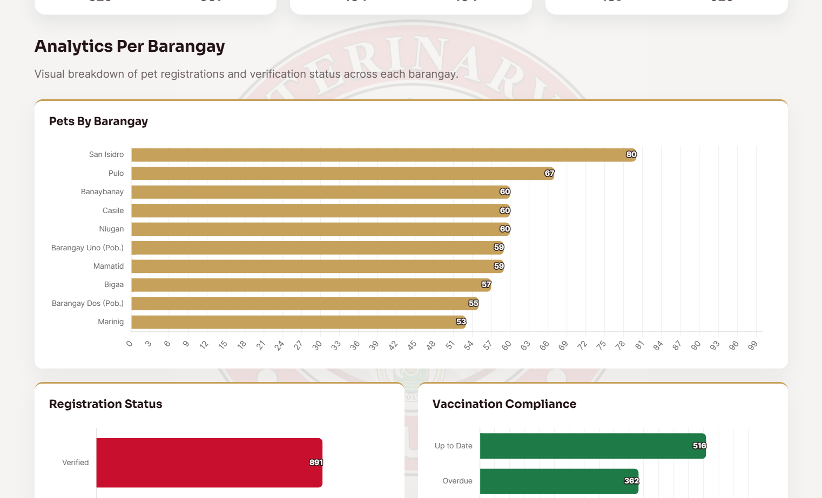
The Administrator Dashboard is designed to provide a consolidated view of key indicators and summarized system information for administrative monitoring. It was developed based on the requirement that the administrator should have an overview of important records without opening each module individually. Its major functions include presenting summary counts and key indicators derived from the stored records. To use the interface, the administrator opens the dashboard and reviews the displayed indicators and summaries. After the dashboard loads, the system retrieves and aggregates the relevant records and presents the resulting values through the dashboard interface for administrative monitoring.

Figure 22. The analytics and reporting interface used by the administrator to examine summarized system data and available reports.
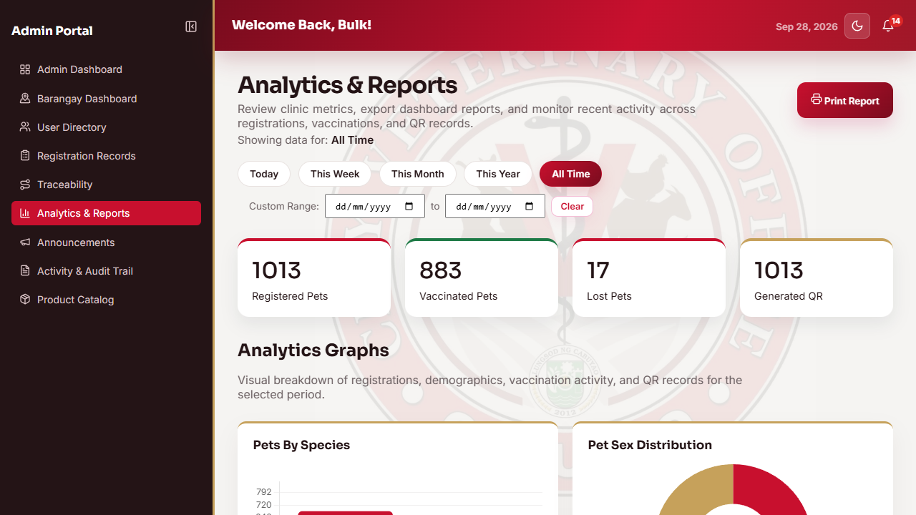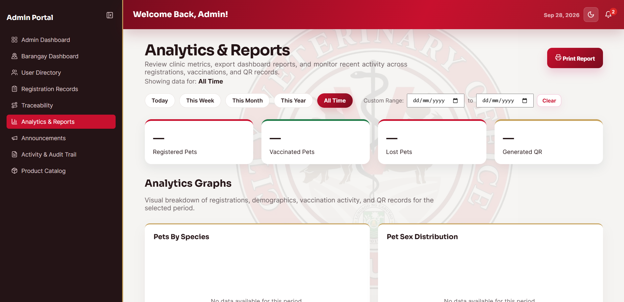

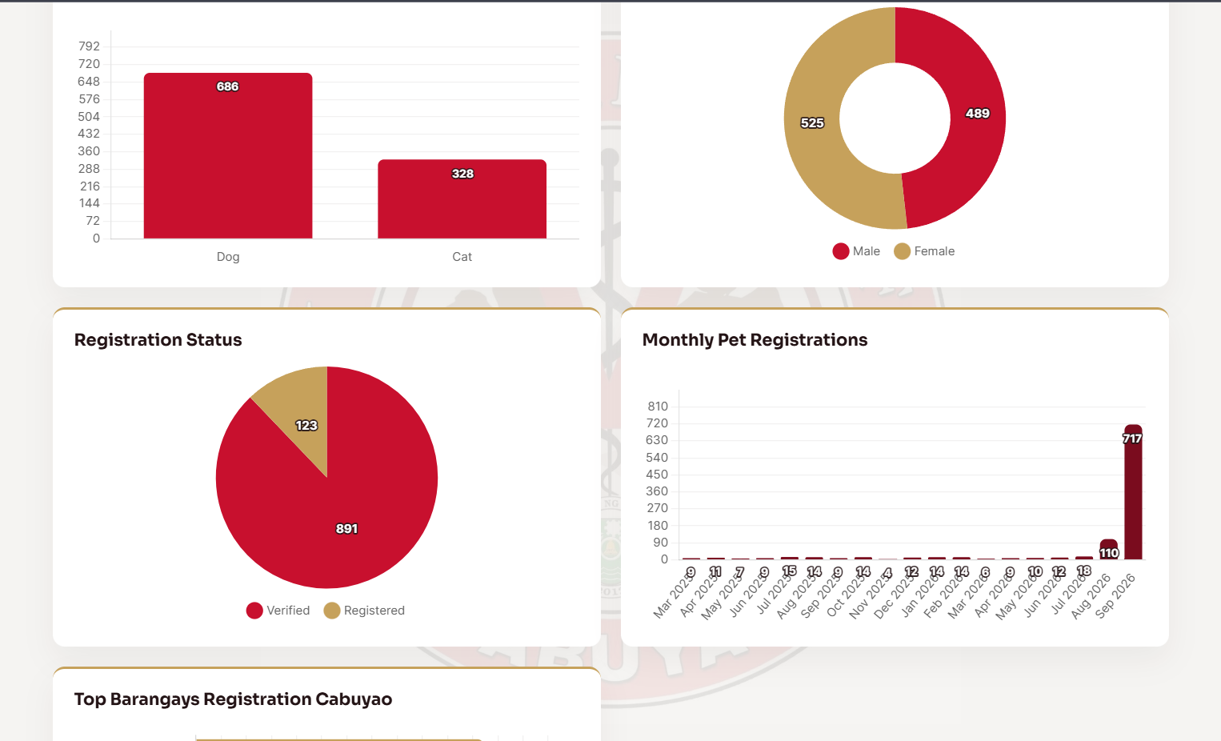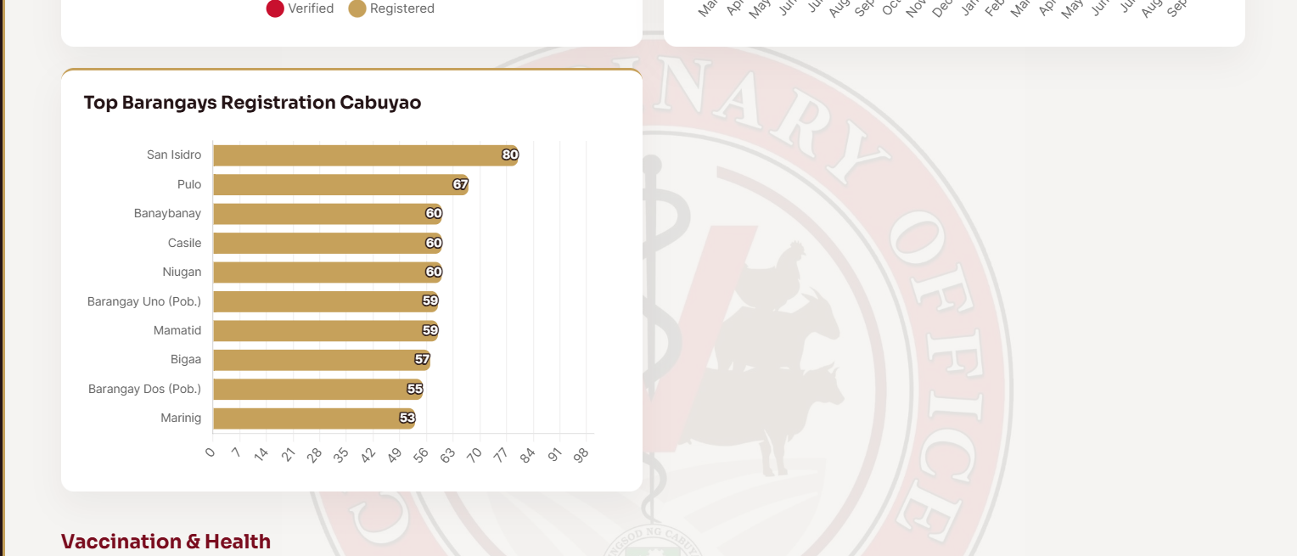

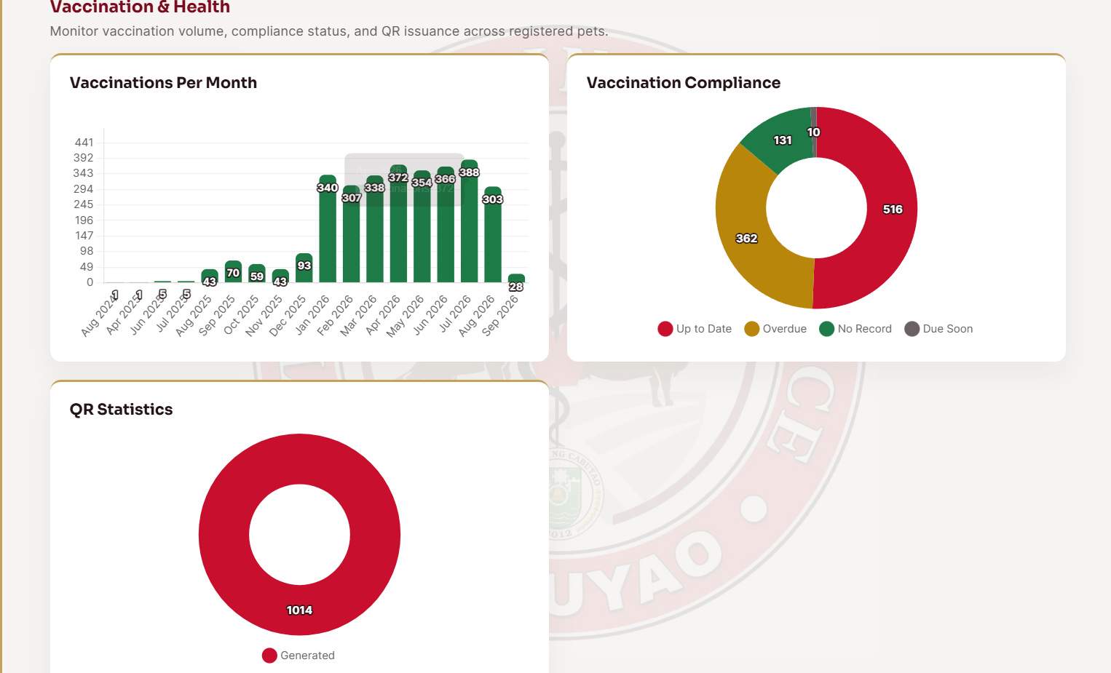

The Analytics and Reporting interface is designed to support administrative review of summarized data and available reports generated from the system records. It was developed based on the requirement that the administrator should be able to examine system data in summarized form for monitoring and reporting purposes. Its major functions include viewing analytics, examining trends or summarized results, and using the available report-generation or export functions. To use the interface, the administrator selects the needed analytics or report option and reviews the resulting information. After the request is processed, the system retrieves and aggregates the relevant records and presents the results through the available charts, tables, summaries, or report output.

Figure 23. The barangay dashboard presenting the distribution of pet registration data by barangay in Cabuyao City.
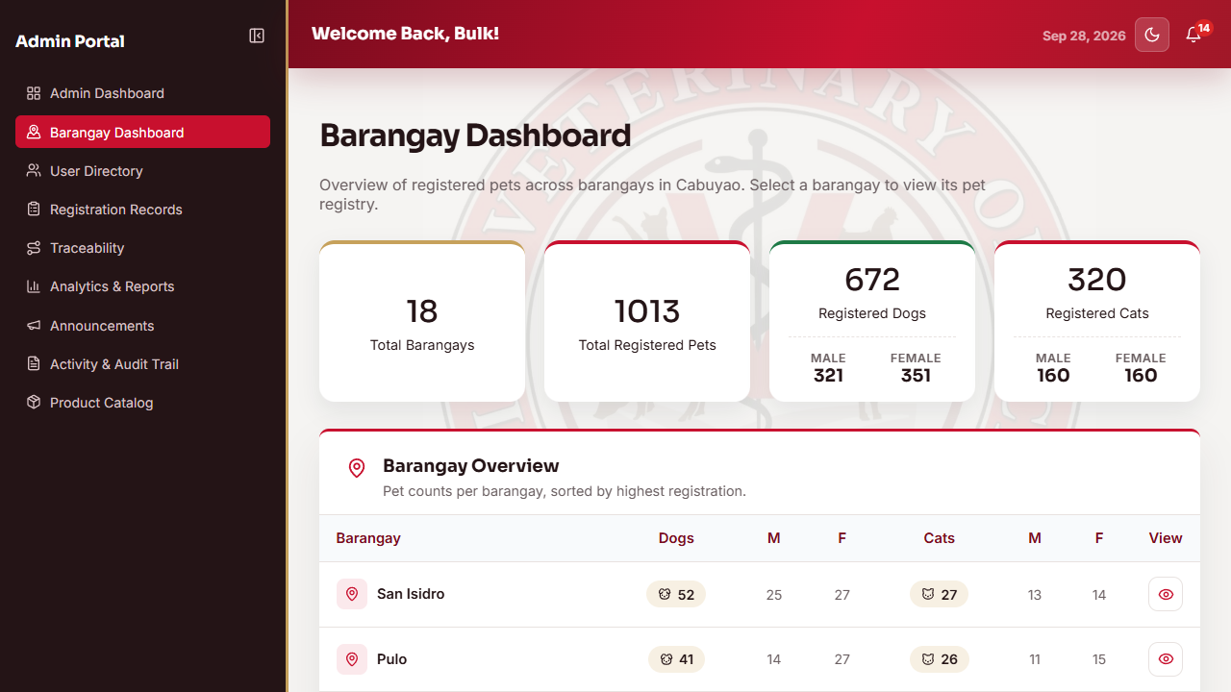
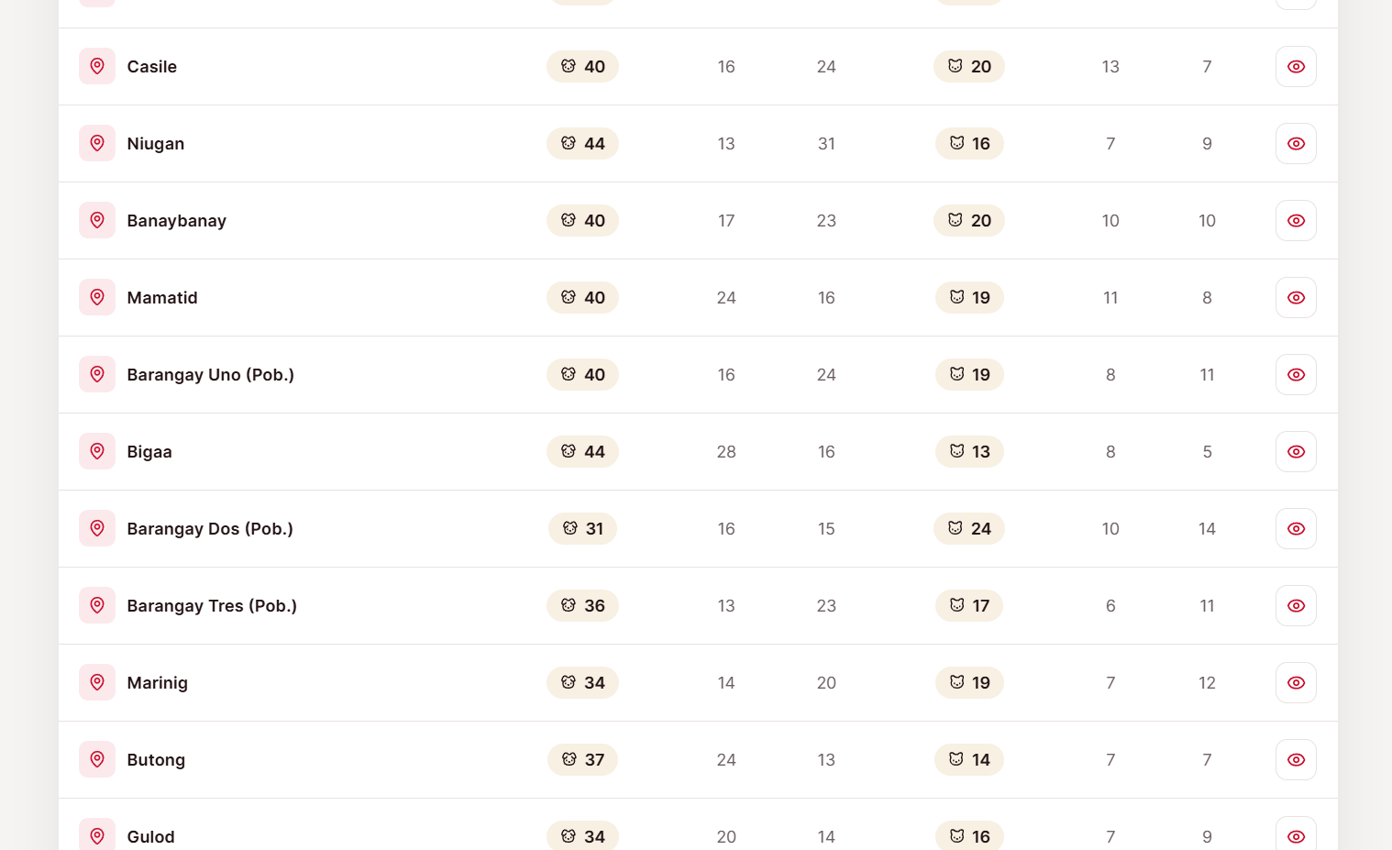

The Barangay Dashboard is designed to present pet registration information according to barangay for administrative monitoring. It was developed based on the requirement that the administrator should be able to examine the geographic distribution of registered pets within Cabuyao City. Its major functions include displaying barangay-level registration counts and presenting the distribution of records in a summarized dashboard view. To use the interface, the administrator opens the Barangay Dashboard and reviews the displayed barangay data or selects the available view for a specific barangay. After the data are retrieved, the system aggregates the registration records by barangay and presents the resulting distribution through the dashboard.

Results of Unit Testing Per Module

Unit testing was conducted to determine whether the individual functions of each module operate correctly when tested independently by the researchers. The purpose of the test was to demonstrate that each component of the system performs according to its intended function before the components are integrated with one another. Table 1 presents the results of the unit testing for the modules of the system.

Table 1. Results of Unit Testing Per Module

A total of seventeen (17) functions were tested across the seven (7) modules of the system. All seventeen (17) functions passed the unit test, which is equivalent to a passing rate of one hundred percent (100%). No test case failed during the conduct of the test, and the individual components were found to perform according to their expected behavior when tested independently.

During the testing, a few minor issues were noted, including incomplete validation messages on certain input fields and minor formatting inconsistencies in the displayed results. These issues were immediately corrected by the researchers, and the affected functions were retested and subsequently passed. The corrections involved updating validation logic to display clearer error messages and adjusting the alignment of table columns in the reporting interface.

The results of the unit testing show that the core functions of each module, including user authentication, pet registration, QR code generation, vaccination recording, payment and Payment Receipt processing, record management, and report generation, work correctly on their own. This provided the researchers with the confidence to proceed with the integration of the modules.

Results of Integration Testing

Integration testing was conducted to determine whether the different modules and components of the system work correctly when combined. While unit testing checks individual components, integration testing checks whether those components can properly communicate, exchange data, and work together. Table 2 presents the results of the integration testing conducted for the system.

Table 2. Results of Integration Testing

A total of eight (8) integration test scenarios were executed to verify the interaction of the modules of the system. The scenarios covered the communication between the authentication module and the pet registration module, the exchange of data between the pet registration module and the QR code module, the integration of the vaccination module with the notification service, the connection of the payment

module with the consultation workflow, the interaction between the records management module and the PDF generation service, the integration of the analytics module with the database and reporting functions, the data flow from consultation recording to payment transaction creation, and the offline draft submission process with the registration module.

All eight (8) test scenarios passed, which indicates that the modules successfully interacted with one another and that data were transferred correctly between modules. The modules communicated correctly, the data that were transferred between modules were complete and accurate, and the integrated functions produced the expected results. No errors were encountered during the conduct of the integration testing, and no corrections were required.

The success of the integration testing confirmed that the system operates as one cohesive application and that the flows that cut across multiple modules, particularly the registration-to-QR process, the vaccination-to-notification process, the consultation-to-payment process, and the offline draft-to-registration submission process, work as designed.

II. Performance Evaluation Results by the Stakeholders

This section presents the results of the evaluation of the developed system by the identified respondents or evaluators. The system was evaluated by two (2) groups of respondents, namely the five (5) IT experts and the fifty (50) end users. The evaluation instruments used were adopted questionnaires patterned after the ISO/IEC 25010 quality characteristics. The IT experts evaluated the system in terms of Functional Suitability, Performance Efficiency, Usability, Reliability, and Security using thirty (30) indicators, while the end users evaluated the system in terms of Functional Suitability, Performance Efficiency, and Usability using eighteen (18) indicators.

Each indicator was rated by the respondents using a five-point Likert scale. The responses were tallied, and the weighted mean of each indicator and of each quality characteristic was computed by dividing the total weighted value by the number of respondents. The obtained weighted mean was interpreted using the range and verbal interpretation presented in Table 3.

Table 3. Weighted Mean Range and Verbal Interpretation

III. Performance Evaluation Results by the IT Experts

The system was evaluated by five (5) IT experts, composed of software engineers, an IT head, and an IT monitoring assistant, who assessed the system based on their technical expertise. Table 4 presents the results of the evaluation for each indicator in the five quality characteristics, while Table 5 presents the summary of the evaluation per quality characteristic.

Table 4. Results of the Evaluation of the System by the IT Experts

Table 5. Summary of the Evaluation by the IT Experts per Quality Characteristics

As shown in Table 5, the overall weighted mean of the evaluation by the IT experts is 4.95, which is described as Strongly Agree. This indicates that the IT experts strongly agreed that the developed system met the requirements set for the study and that it is highly acceptable in terms of the quality characteristics evaluated.

Among the five quality characteristics, Usability obtained the highest weighted mean of 5.00, which indicates that the IT experts strongly agreed that the interface of the system is easy to understand, that the navigation can be learned without extensive training, and that the system provides clear feedback to the users. This was followed by Reliability and Security, which both obtained a weighted mean of 4.97, indicating that the system consistently performed its expected functions, preserved the records stored in the system, and protected the records from unauthorized access. Functional Suitability obtained a weighted mean of 4.93, which indicates that the system provides the required functions for pet registration, vaccination monitoring, QR-based identification, payment monitoring, record management, and data analytics. Performance Efficiency obtained the lowest weighted mean of 4.87, although it is still described as Strongly Agree. This indicates that the IT experts strongly agreed that the system maintained acceptable response times and stable operation, with the slightly lower rating observed in the time behavior indicators during QR-based record retrieval.

At the indicator level, twenty-two (22) out of the thirty (30) indicators obtained the highest weighted mean of 5.00, while the remaining eight (8) indicators obtained a weighted mean of 4.80. All indicators were interpreted as Strongly Agree. The result implies that the system is technically sound and that its major functionalities, particularly those involving security, usability, and record integrity, were highly regarded by the IT experts. Minor opportunities for improvement were noted in the time-based and concurrency-related indicators, which were considered acceptable given the scale and environment in which the system will operate.

IV. Performance Evaluation Results by the End Users

The system was also evaluated by fifty (50) end users who assessed the system in terms of Functional Suitability, Performance Efficiency, and Usability using eighteen (18) indicators. Table 6 presents the results of the evaluation for each indicator, while Table 7 presents the summary of the evaluation per quality characteristic.

Table 6. Results of the Evaluation of the System by the End Users

Table 7. Summary of the Evaluation by the End Users per Quality Characteristics

As shown in Table 7, the overall weighted mean of the evaluation by the end users is 4.25, which is described as Strongly Agree. This indicates that the end users strongly agreed that the system is acceptable and that it served its purpose in the registration, identification, vaccination, and payment processes of the City Veterinary Animal Clinic.

Among the three quality characteristics, Performance Efficiency obtained the highest weighted mean of 4.28. This indicates that the end users strongly agreed that the system loaded pet records, displayed search results, responded to QR scans, and retrieved records within acceptable time. Functional Suitability obtained a weighted mean of 4.25, which indicates that the system provided the forms for pet owner and pet registration, generated the unique QR codes, displayed the correct records after scanning, and recorded vaccination history and Payment Receipt numbers. Usability obtained a weighted mean of 4.22, which is the lowest among the three characteristics but is still interpreted as Strongly Agree. This indicates that the end users found the labels, navigation, and feedback messages of the system clear and easy to understand.

At the indicator level, twelve (12) out of the eighteen (18) indicators obtained weighted means within the range of 4.20 to 5.00 and were interpreted as Strongly Agree, while the remaining six (6) indicators obtained weighted means within the range of 3.40 to 4.19 and were interpreted as Agree. The highest rated indicator was Item 7, the system loads pet records within an acceptable amount of time, which obtained a weighted mean of 4.44, followed by Item 18, the system provides a clear message after a submitted action, with a weighted mean of 4.40. The lowest rated indicator was Item 5, the system records the vaccination history of a registered pet, which obtained a weighted mean of 4.04 and was interpreted as Agree. The slightly lower rating for this indicator suggests that the functionality of the vaccination module may be reinforced further through additional enhancements and orientation for the end users. Nevertheless, since no indicator was rated below Agree, the overall evaluation indicates that the system is highly acceptable to the end users. The results of the evaluation by both the IT experts and the end users substantiate the conclusion that the developed system effectively addresses the objectives of the study.

Note: The testing and evaluation results presented in the preceding tables reflect only the actual test cases conducted and the actual responses collected by the researchers.
Module |  |  |  | Function Tested |  |  | Expected Result |  |  | Actual Result |  |  |  |  |  | Status
User Management and Authentication |  |  |  | User login and authentication |  |  | Valid credentials allow access; invalid credentials are rejected |  |  | User logged in successfully; invalid login rejected with a message |  |  |  |  |  | Passed
User Management and Authentication |  |  |  | Registration of pet owner account |  |  | Owner information is saved and the account becomes usable |  |  | Account successfully created and saved in the database |  |  |  |  |  | Passed
User Management and Authentication |  |  |  | Creation of staff and veterinarian accounts |  |  | Only the admin can create staff or veterinarian accounts |  |  | Staff and veterinarian accounts created with the setup link |  |  |  |  |  | Passed
User Management and Authentication |  |  |  | Role-based access control |  |  | Each role can only access its authorized modules |  |  | Appropriate role-based interface displayed; unauthorized access blocked |  |  |  |  |  | Passed
Pet Registration |  |  |  | Registration of a new pet |  |  | Pet information is saved with an auto-generated pet code |  |  | Pet successfully registered with a unique pet code |  |  |  |  |  | Passed
Pet Registration |  |  |  | Duplicate record prevention |  |  | Duplicate pet records are prevented |  |  | Duplicate entries were blocked by the system |  |  |  |  |  | Passed
Pet Registration |  |  |  | Uploading of pet photo |  |  | Pet photo is uploaded and stored |  |  | Pet photo uploaded successfully |  |  |  |  |  | Passed
QR Code Generation and Traceability |  |  |  | Generation of QR code after verification |  |  | A unique QR code is generated for the verified pet |  |  | QR code generated and saved |  |  |  |  |  | Passed
QR Code Generation and Traceability |  |  |  | Retrieval of pet record through QR scan |  |  | Scanning the QR code displays the correct pet record |  |  | Correct pet record displayed after scanning |  |  |  |  |  | Passed
Vaccination Management |  |  |  | Recording of a vaccination |  |  | Vaccination record is saved and the next due date is computed |  |  | Vaccination recorded; next due date computed |  |  |  |  |  | Passed
Vaccination Management |  |  |  | Computation of vaccination status |  |  | Status reflects Updated, Due, or Overdue |  |  | Vaccination status updated correctly |  |  |  |  |  | Passed
Payment and Payment Receipt Monitoring |  |  |  | Submission and linking of Payment Receipt |  |  | Payment Receipt is recorded and linked to the pet registration |  |  | Payment Receipt successfully linked to the record |  |  |  |  |  | Passed
Payment and Payment Receipt Monitoring |  |  |  | Verification of submitted payment |  |  | Payment status is updated after verification |  |  | Payment successfully marked as verified |  |  |  |  |  | Passed
Records Management |  |  |  | Recording of consultation and medicine records |  |  | Consultation and medicine records are saved |  |  | Records successfully saved in the database |  |  |  |  |  | Passed
Records Management |  |  |  | Generation and issuance of a requested record |  |  | Requested record is generated as a PDF file |  |  | PDF file generated and record issued |  |  |  |  |  | Passed
Data Analytics and Reporting |  |  |  | Generation of dashboard summaries |  |  | Aggregated indicators are displayed |  |  | Dashboard summaries displayed correctly |  |  |  |  |  | Passed
Data Analytics and Reporting |  |  |  | Export of reports |  |  | Reports are exported to PDF or Excel |  |  | Report files successfully exported |  |  |  |  |  | Passed
Integrated Modules |  |  |  | Test Scenario |  | Expected Result |  |  |  | Actual Result |  |  |  |  |  | Status
User Management + Pet Registration |  |  |  | Register an owner account and register a pet |  | The owner can log in and register a pet |  |  |  | Owner registered and logged in; pet registered successfully |  |  |  |  |  | Passed
Pet Registration + QR Code and Traceability |  |  |  | Verify a pet registration |  | A QR code is generated and linked to the pet profile |  |  |  | QR code generated on verification and traced by scanning |  |  |  |  |  | Passed
QR Scan + Pet Records + Database |  |  |  | Scan a QR code to fetch a pet record |  | The system returns the correct pet record |  |  |  | Correct pet record displayed after scanning |  |  |  |  |  | Passed
Vaccination Management + Notification + Database |  |  |  | Record a vaccination |  | Record is saved, next due date is computed, and the owner is notified |  |  |  | Vaccination saved; owner notified of the update |  |  |  |  |  | Passed
Payment and Payment Receipt + Pet Records |  |  |  | Link an Payment Receipt to a pet registration |  | The receipt and payment are linked to the correct pet |  |  |  | Payment Receipt successfully linked to the correct registration |  |  |  |  |  | Passed
Data Analytics + Database + Reporting |  |  |  | Generate summaries and export reports |  | Aggregated data are computed and exported |  |  |  | Summaries generated; PDF and Excel export successful |  |  |  |  |  | Passed
Records Management + PDF + Notification |  |  |  | Request and issue a record |  | The record is generated as a PDF and the owner is notified |  |  |  | Record issued, PDF downloaded, and owner notified |  |  |  |  |  | Passed
Authentication + Role-Based Access Control |  |  |  | Log in as each role and access modules |  | Role-based navigation is enforced |  |  |  | Each role accessed only its authorized modules |  |  |  |  |  | Passed
Scale |  |  |  |  | Weighted Mean Range |  |  |  | Verbal Interpretation
5 |  |  |  |  | 4.20 – 5.00 |  |  |  | Strongly Agree
4 |  |  |  |  | 3.40 – 4.19 |  |  |  | Agree
3 |  |  |  |  | 2.60 – 3.39 |  |  |  | Neutral
2 |  |  |  |  | 1.80 – 2.59 |  |  |  | Disagree
1 |  |  |  |  | 1.00 – 1.79 |  |  |  | Strongly Disagree
No. |  |  | Indicators |  |  |  |  |  |  |  |  |  | Weighted Mean |  |  |  |  | Verbal Interpretation
A. Functional Suitability
1 |  |  | The system provides the required data fields for pet owner registration. |  |  |  |  |  |  |  |  |  | 5.00 |  |  |  |  | Strongly Agree
2 |  |  | The system provides the required data fields for pet registration. |  |  |  |  |  |  |  |  |  | 5.00 |  |  |  |  | Strongly Agree
3 |  |  | The system generates a unique QR identifier for each registered pet. |  |  |  |  |  |  |  |  |  | 4.80 |  |  |  |  | Strongly Agree
4 |  |  | The system retrieves the correct pet record from a scanned QR identifier. |  |  |  |  |  |  |  |  |  | 5.00 |  |  |  |  | Strongly Agree
5 |  |  | The system provides search filtering mechanisms for locating stored records. |  |  |  |  |  |  |  |  |  | 5.00 |  |  |  |  | Strongly Agree
6 |  |  | The system provides analytics summaries for the defined pet-related indicators. |  |  |  |  |  |  |  |  |  | 4.80 |  |  |  |  | Strongly Agree
B. Performance Efficiency
7 |  |  | The system maintains acceptable response time when retrieving centralized records. |  |  |  |  |  |  |  |  |  | 4.80 |  |  |  |  | Strongly Agree
8 |  |  | The system maintains acceptable response time during QR-based record retrieval. |  |  |  |  |  |  |  |  |  | 4.80 |  |  |  |  | Strongly Agree
9 |  |  | The system maintains stable operation during multiple active user sessions. |  |  |  |  |  |  |  |  |  | 4.80 |  |  |  |  | Strongly Agree
10 |  |  | The system manages database resources appropriately during record transactions. |  |  |  |  |  |  |  |  |  | 5.00 |  |  |  |  | Strongly Agree
11 |  |  | The system accommodates the expected volume of pet records within the database. |  |  |  |  |  |  |  |  |  | 5.00 |  |  |  |  | Strongly Agree
12 |  |  | The system supports concurrent access to its core functions. |  |  |  |  |  |  |  |  |  | 4.80 |  |  |  |  | Strongly Agree
C. Usability
13 |  |  | The system's interface identifies the purpose of its primary functions. |  |  |  |  |  |  |  |  |  | 5.00 |  |  |  |  | Strongly Agree
14 |  |  | The system presents pet records using understandable field labels. |  |  |  |  |  |  |  |  |  | 5.00 |  |  |  |  | Strongly Agree
15 |  |  | The system's navigation structures can be learned without extensive training. |  |  |  |  |  |  |  |  |  | 5.00 |  |  |  |  | Strongly Agree
16 |  |  | The system uses recognizable controls for commonly used operations. |  |  |  |  |  |  |  |  |  | 5.00 |  |  |  |  | Strongly Agree
17 |  |  | The system provides clear validation feedback for invalid inputs. |  |  |  |  |  |  |  |  |  | 5.00 |  |  |  |  | Strongly Agree
18 |  |  | The system provides confirmation feedback after completed transactions. |  |  |  |  |  |  |  |  |  | 5.00 |  |  |  |  | Strongly Agree
D. Reliability
19 |  |  | The system completes record transactions without unexpected system errors. |  |  |  |  |  |  |  |  |  | 5.00 |  |  |  |  | Strongly Agree
20 |  |  | The system preserves stored record values after an update operation. |  |  |  |  |  |  |  |  |  | 5.00 |  |  |  |  | Strongly Agree
21 |  |  | The system remains accessible during normal clinic operations. |  |  |  |  |  |  |  |  |  | 5.00 |  |  |  |  | Strongly Agree
22 |  |  | The system maintains core functionality when a temporary processing error occurs. |  |  |  |  |  |  |  |  |  | 4.80 |  |  |  |  | Strongly Agree
23 |  |  | The system restores normal operations after an unexpected interruption. |  |  |  |  |  |  |  |  |  | 5.00 |  |  |  |  | Strongly Agree
24 |  |  | The system preserves saved records after service recovery. |  |  |  |  |  |  |  |  |  | 5.00 |  |  |  |  | Strongly Agree
E. Security
25 |  |  | The system restricts pet owner records to authorized accounts. |  |  |  |  |  |  |  |  |  | 5.00 |  |  |  |  | Strongly Agree
26 |  |  | The system restricts payment-related records to authorized accounts. |  |  |  |  |  |  |  |  |  | 5.00 |  |  |  |  | Strongly Agree
27 |  |  | The system validates submitted data before storing it in the database. |  |  |  |  |  |  |  |  |  | 5.00 |  |  |  |  | Strongly Agree
28 |  |  | The system prevents unauthorized modifications of stored records. |  |  |  |  |  |  |  |  |  | 5.00 |  |  |  |  | Strongly Agree
29 |  |  | The system authenticates user credentials before granting access. |  |  |  |  |  |  |  |  |  | 4.80 |  |  |  |  | Strongly Agree
30 |  |  | The system applies access permissions according to assigned user roles. |  |  |  |  |  |  |  |  |  | 5.00 |  |  |  |  | Strongly Agree
Quality Characteristic |  |  |  |  |  |  |  | Weighted Mean |  |  |  |  |  | Verbal Interpretation
A. Functional Suitability |  |  |  |  |  |  |  | 4.93 |  |  |  |  |  | Strongly Agree
B. Performance Efficiency |  |  |  |  |  |  |  | 4.87 |  |  |  |  |  | Strongly Agree
C. Usability |  |  |  |  |  |  |  | 5.00 |  |  |  |  |  | Strongly Agree
D. Reliability |  |  |  |  |  |  |  | 4.97 |  |  |  |  |  | Strongly Agree
E. Security |  |  |  |  |  |  |  | 4.97 |  |  |  |  |  | Strongly Agree
Overall Weighted Mean |  |  |  |  |  |  |  | 4.95 |  |  |  |  |  | Strongly Agree
No. | Indicators |  |  |  |  |  |  |  |  |  | Weighted Mean |  |  |  | Verbal Interpretation
A. Functional Suitability
1 | The system provides a form for recording pet owner information. |  |  |  |  |  |  |  |  |  | 4.38 |  |  |  | Strongly Agree
2 | The system provides a form for recording pet information. |  |  |  |  |  |  |  |  |  | 4.32 |  |  |  | Strongly Agree
3 | The system provides a unique QR code for each registered pet. |  |  |  |  |  |  |  |  |  | 4.16 |  |  |  | Agree
4 | The system displays the corresponding pet record after the QR code is scanned. |  |  |  |  |  |  |  |  |  | 4.28 |  |  |  | Strongly Agree
5 | The system records the vaccination history of a registered pet. |  |  |  |  |  |  |  |  |  | 4.04 |  |  |  | Agree
6 | The system associates an Payment Receipt number with the appropriate pet registration record. |  |  |  |  |  |  |  |  |  | 4.30 |  |  |  | Strongly Agree
B. Performance Efficiency
7 |  | The system loads pet records within an acceptable amount of time. |  |  |  |  |  |  |  |  |  | 4.44 |  |  |  |  | Strongly Agree
8 |  | The system displays search results without noticeable delay. |  |  |  |  |  |  |  |  |  | 4.22 |  |  |  |  | Strongly Agree
9 |  | The system responds promptly when a QR code is scanned. |  |  |  |  |  |  |  |  |  | 4.12 |  |  |  |  | Agree
10 |  | The system responds promptly when registration information is submitted. |  |  |  |  |  |  |  |  |  | 4.34 |  |  |  |  | Strongly Agree
11 |  | The system retrieves the requested pet record within an acceptable time. |  |  |  |  |  |  |  |  |  | 4.30 |  |  |  |  | Strongly Agree
12 |  | The system displays analytics summaries within the required response time. |  |  |  |  |  |  |  |  |  | 4.26 |  |  |  |  | Strongly Agree
C. Usability
13 |  | The system labels clearly identify the purpose of each function. |  |  |  |  |  |  |  |  |  | 4.26 |  |  |  |  | Strongly Agree
14 |  | The system presents pet information in a format that is easy to understand. |  |  |  |  |  |  |  |  |  | 4.10 |  |  |  |  | Agree
15 |  | The system can be learned without extensive assistance. |  |  |  |  |  |  |  |  |  | 4.12 |  |  |  |  | Agree
16 |  | The system's navigation makes it easy to locate needed functions. |  |  |  |  |  |  |  |  |  | 4.18 |  |  |  |  | Agree
17 |  | The system identifies invalid information entered into a form. |  |  |  |  |  |  |  |  |  | 4.28 |  |  |  |  | Strongly Agree
18 |  | The system provides a clear message after a submitted action. |  |  |  |  |  |  |  |  |  | 4.40 |  |  |  |  | Strongly Agree
Quality Characteristic |  |  |  |  |  |  |  | Weighted Mean |  |  |  |  |  | Verbal Interpretation
A. Functional Suitability |  |  |  |  |  |  |  | 4.25 |  |  |  |  |  | Strongly Agree
B. Performance Efficiency |  |  |  |  |  |  |  | 4.28 |  |  |  |  |  | Strongly Agree
C. Usability |  |  |  |  |  |  |  | 4.22 |  |  |  |  |  | Strongly Agree
Overall Weighted Mean |  |  |  |  |  |  |  | 4.25 |  |  |  |  |  | Strongly Agree

